Dr. Rima Kumari: Date: 17/08/2020
Online class and e- content for MSc IIIrd semester students
Date and Time | Online class medium | E. content topic
17/08/2020  01:20 p.m to 2:10 p.m | Via Google meet  Link: Meeting URL: https://meet.google.com/nof-pkai-aur | Prokaryotic Reproduction,  Difference between Eukaryotes and Prokaryotes

Prokaryotic Reproduction
Prokaryotes reproduce asexually by binary fission; they can also exchange genetic material by transformation, transduction, and conjugation.
- Binary fission: Binary fission is a type of reproduction in which the chromosome is replicated and the resultant prokaryote is an exact copy of the parental prokaryate, thus leaving no opportunity for genetic diversity. It is the process whereby a cell divides asexually to produce two daughter cells
- transformation: Transformation is a type of prokaryotic reproduction in which a prokaryote can take up DNA found within the environment that has originated from other prokaryotes, especially if pathogenic
- transduction: Transduction is a type of prokaryotic reproduction in which a prokaryote is infected by a virus which injects short pieces of chromosomal DNA from one bacterium to another. horizontal gene transfer mechanism in prokaryotes where genes are transferred using a virus

- Conjugation: Conjugation is a type of prokaryotic reproduction in which DNA is transferred between prokaryotes by means of a pilus. the temporary fusion of organisms, especially as part of sexual reproduction by using sex pili
Difference between Eukaryotes and Prokaryotes:
Nucleus | Present | Absent
Number of chromosomes | More than one | One--but not true chromosome: Plasmids
Cell Type | Usually multicellular, some unicellular | Usually unicellular (some cyanobacteria may be multicellular)
True Membrane bound Nucleus | Present | Absent
Example | Animals and Plants | Bacteria and Archaea
Genetic Recombination | Meiosis and fusion of gametes | Partial, undirectional transfers DNA
Lysosomes and peroxisomes | Present | Absent
Microtubules | Present | Absent or rare
Endoplasmic reticulum | Present | Absent
Mitochondria | Present | Absent
Cytoskeleton | Present | May be absent
DNA wrapping on proteins. | Eukaryotes wrap their DNA around proteins called histones. | Multiple proteins act together to fold and condense prokaryotic DNA. Folded DNA is then organized into a variety of conformations that are supercoiled and wound around tetramers of the Histone protein.
Ribosomes | larger | smaller
Vesicles | Present | Present
Golgi apparatus | Present | Absent
Chloroplasts | Present (in plants) | Absent; chlorophyll scattered in the cytoplasm
Flagella | Microscopic in size; membrane bound; usually arranged as nine doublets surrounding two singlets | Submicroscopic in size, composed of only one fiber
Permeability of Nuclear Membrane | Selective | not present
Plasma membrane with steroid | Yes | Usually no
Cell wall | Only in plant cells and fungi (chemically simpler) | Usually chemically complex
Vacuoles | Present | Present
Cell size | 10-100um | 1-10um

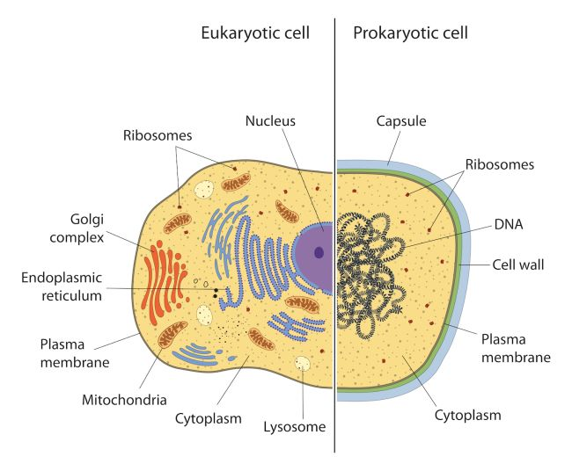
The most fundamental difference is that eukaryotes do have "true" nuclei containing their DNA, whereas the genetic material in prokaryotes is not membrane-bound.
- In eukaryotes, the mitochondria and chloroplasts perform various metabolic processes and are believed to have been derived from endosymbiotic bacteria. In prokaryotes similar processes occur across the cell membrane; endosymbionts are extremely rare.
- The cell walls of prokaryotes are generally formed of a different molecule (peptidoglycan) to those of eukaryotes (many eukaryotes do not have a cell wall at all).
- Prokaryotes are usually much smaller than eukaryotic cells.
- Prokaryotes also differ from eukaryotes in that they contain only a single loop of stable chromosomal DNA stored in an area named the nucleoid, while eukaryote DNA is found on tightly bound and organised chromosomes. Although some eukaryotes have satellite DNA structures called plasmids, these are generally regarded as a prokaryote feature and many important genes in prokaryotes are stored on plasmids.
- Prokaryotes have a larger surface area to volume ratio giving them a higher metabolic rate, a higher growth rate and consequently a shorter generation time compared to Eukaryotes.
- Genes
  - Prokaryotes also differ from eukaryotes in the structure, packing, density, and arrangement of their genes on the chromosome. Prokaryotes have incredibly compact genomes compared to eukaryotes, mostly because prokaryote genes lack introns and large non-coding regions between each gene.
  - Whereas nearly 95% of the human genome does not code for proteins or RNA or includes a gene promoter, nearly all of the prokaryote genome codes or controls something.
  - Prokaryote genes are also expressed in groups, known as operons, instead of individually, as in eukaryotes.
  - In a prokaryote cell, all genes in an operon(three in the case of the famous lac operon) are transcribed on the same piece of RNA and then made into separate proteins, whereas if these genes were native to eukaryotes, they each would have their own promoter and be transcribed on their own strand of mRNA. This lesser degree of control over gene expression contributes to the simplicity of the prokaryotes as compared to the eukaryotes.
Nucleus/DNA: Eukaryotic cells have a nucleus surrounded by a nuclear envelope that consists of two lipid membranes. The nucleus holds the eukaryotic cell's DNA. Prokaryotic cells do not have a nucleus; rather, they have a membraneless nucleoid region. he entire DNA in a cell can be found in individual pieces known as chromosomes. Eukaryotic cells have many chromosomes which undergo meiosis and mitosis during cell division, while most prokaryotic cells consist of just circular DNA structure.
Organelles in Eukaryotic Cells: Eukaryotic cells have several other membrane-bound organelles not found in prokaryotic cells. These include the mitochondria (convert food energy into adenosine triphosphate, or ATP, to power biochemical reactions); rough and smooth endoplasmic reticulum (an interconnected network of membrane-enclosed tubules that transport synthesized proteins); golgi complex (sorts and packages proteins for secretion); and in the case of plant cells, chloroplasts (conduct photosynthesis). All of these organelles are located in the eukaryotic cell's cytoplasm
Ribosomes: In eukaryotic cells, the ribosomes are bigger, more complex and bound by a membrane. They can be found in various places: Sometimes in the cytoplasm; on the endoplasmic reticulum; or attached to the nuclear membrane (covering on the nucleus). In prokaryotic cells, the ribosomes are 70 S sub-unit scattered and floating freely throughout the cytoplasm. In eukaryotes, both 70S and 80 S sub unit of ribosomes present.

Reproduction: Most eukaryotes reproduce sexually (although some protists and single-celled fungi may reproduce through mitosis, which is functionally similar to asexual reproduction). Prokaryotes reproduce asexually, resulting in the offspring being an exact clone of the parent. Some prokaryotic cells also have pili, which are adhesive hair-like projections used to exchange genetic material during a type of sexual process called conjugation. Conjugation can occur in bacteria, protozoans and some algae and fungi.

Cell Walls: Most prokaryotic cells have a rigid cell wall that surrounds the plasma membrane and gives shape to the organism. In eukaryotes, vertebrates don't have a cell wall but plants do. The cell walls of prokaryotes differ chemically from the eukaryotic cell walls of plant cells, which are primarily made of cellulose. In bacteria, for example, the cell walls are composed of peptidoglycans

