Dr. Rima Kumari: Date: 04/08/2020
Online class and e- content for BSc IIIrd year students

Date and Time | Online class medium | E. content topic
04/08/2020  01:00 p.m to 1.20 p.m | Via Google meet  Link: Meeting URL: https://meet.google.com/jkk-ipyy-smv | Mechanism of enzyme Action, Allosteric Enzyme, Enzyme Inhibition

Mechanism of enzyme Action
An enzyme attach the substrates to its active site, catalyzes the chemical reaction by which products are formed, and then allows the products to dissociate (separate from the enzyme surface). The combination formed by an enzyme and its substrates is called the enzyme–substrate complex. When two substrates and one enzyme are involved, the complex is called a ternary complex; one substrate and one enzyme are called a binary complex. The substrates are attracted to the active site by electrostatic and hydrophobic forces, which are called non-covalent bonds because they are physical attractions and not chemical bonds. In any chemical reaction, a substrate (S) is converted into a product (P):

S P

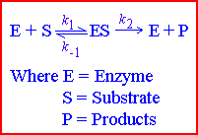
(There may be more than one substrate and more than one product, but that doesn't matter here.) In an enzyme-catalysed reaction, the substrate first binds to the active site of the enzyme to form an enzyme-substrate (ES) complex, then the substrate is converted into product whilst attached to the enzyme, and finally the product is released, thus allowing the enzyme to start all over again (see right)

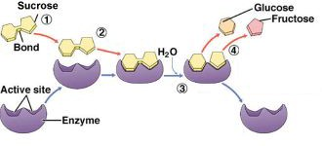

An example is the action of the enzyme sucrase (enzyme) hydrolysing sucrose into glucose and fructose

Enzyme substrate interaction
A model for enzyme-substrate interaction suggesting that the enzyme and the substrate possess specific complementary geometric shapes that fit exactly into one another.
Enzymes are highly specific. They must bind to a specific substrate before they can catalyze a chemical reaction. At present, there are two models, which attempt to explain enzyme specificity: (1) lock-and-key model and (2) induced fit model.

- lock-and-key model
In lock-and-key model, the enzyme-substrate interaction suggests that the enzyme and the substrate possess specific complementary geometric shapes that fit exactly into one another. This theory proposed that the substrate molecule is complementary in shape to that of the active site of enzyme. It was thought that the substrate exactly fitted into the active site of the enzyme molecule like a key fitting into a lock (the now discredited ‘lock and key’ theory). This explained why an enzyme would only work on one substrate (specificity), but failed to explain why the reaction happened. The lock and key model theory first postulated by Emil Fischer in 1894 shows the high specificity of enzymes. However, it does not explain the stabilization of the transition
state that the enzymes achieve.

Main point of the lock and key model
- the enzyme’s active site complements the substrate precisely
- The substrate fits a particular active site like a key fits into a particular lock
- This theory of enzyme-substrate interaction explains how enzymes exhibit specificity for a particular substrate

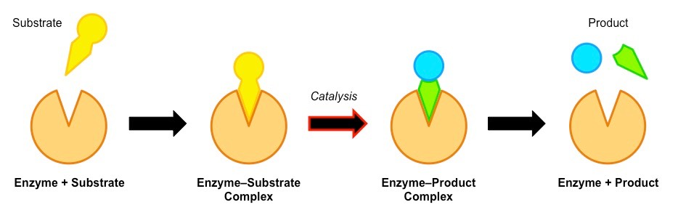

- Induced fit model
As for the induced fit model suggested by Daniel Koshland in 1958, it suggests that the active site continues to change until the substrate is completely bound to the active site of the enzyme, at which point the final shape and charge is determined. Unlike the lock-and-key model, the induced fit model shows that enzymes are rather flexible structures.

Main point of induced fit model
- the active site will undergo a conformational change when exposed to a substrate to improve binding
- it has two advantages compared to the lock and key model as may exhibit broad specificity (e.g. lipase can bind to a variety of lipids), the conformational change stresses bonds in the substrate, increasing reactivity

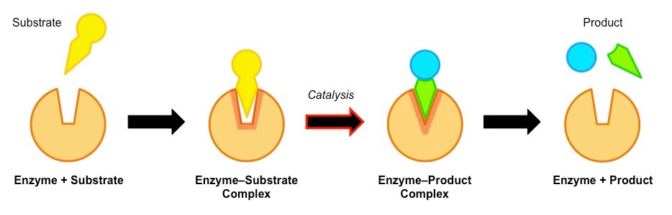

Induced Fit model

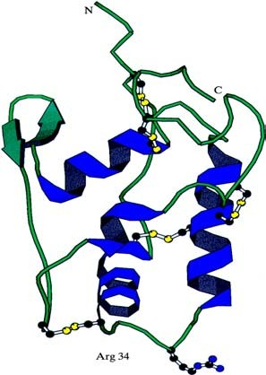
But It is now known that the substrate and the active site both change shape when the enzyme-substrate complex is formed, bending (and thus weakening) the target bonds. For example, if a substrate is to be split, a bond might be stretched by the enzyme, making it more likely to break. Alternatively the enzyme can make the local conditions inside the active site quite different from those outside (such as pH, water concentration, charge), so that the reaction is more likely to happen.

Although enzymes can change the speed of a chemical reaction, they cannot change its direction, otherwise they could make "impossible" reactions happen and break the laws of thermodynamics. So an enzyme can just as easily turn a product into a substrate as turn a substrate into a product, depending on the local concentrations. The transition state is the name given to the distorted shape of the active site and substrate.
This diagram shows another enzyme with its 5
disuphide bridges in yellow and regions of α –helix in blue. The active site is near the region of the arrows.
Activation Energy
Enzymes neither initiate the reaction nor affect the equilibrium ratio of reactants and products. Rather, enzymes accelerate the rate of reaction 10⁸ to 10¹² times in both directions to attain the equilibrium position.
In a reaction where the product has a lower energy than the substrate, the substrate naturally turns into product (i.e. the equilibrium lies in the direction of the product). Before it can change into product, the substrate must overcome an "energy barrier" called the activation energy. The larger the activation energy is, the slower the reaction will be. This is because only a few substrate molecules will have sufficient energy to overcome the activation energy barrier. Imagine pushing boulders over a hump before they can roll down hill, and you have the idea. Most biological reactions have large activation energies, so they without enzymes they happen far too slowly to be useful. Enzymes reduce the activation energy of a reaction so that the kinetic energy of most molecules exceeds the activation energy required and so they can react.

For example, for the catalase reaction (2H₂O₂ → 2H₂O + O₂) the activation energy is 86 kJ mol⁻¹ with no catalyst, 62 kJ mol⁻¹ with an inorganic catalyst, and just 1 kJ mol⁻¹ with the enzyme catalase.

Properties of Enzymes

1. Proteinous nature:

Nearly all enzymes are proteins although some catalytically active RNA molecules have been identified.

2. Colloidal nature:

In the protoplasm, enzymes exist as hydrophilic colloids. Due to colloidal nature, they are isolated by dialysis.

3. Substrate specificity:

A given enzyme only catalyzes one reaction or a similar type of reaction. For example, maltase acts only on maltose while pancreatic lipase acts in a variety of fats. Sometimes, different enzymes may act on the same substrate to produce different end products. The substrate specificity of enzyme is based on amino acids sequence in the catalytic site as well as the optical isomeric form of the substrate.

4. Catalytic properties:

(i) Enzyme require in small concentration for any chemical change,

(ii) They don’t initiate the catalysis but accelerate the rate of catalysis by lowering the activation energy,

(iii) They remain unchanged at the end of reaction,

(iv) Their presence don’t alter the properties of end products,

(v) Enzymes accelerate the forward or reverse reactions to attain the equilibrium but don’t shift the equilibrium,

(vi) Usually enzyme catalyzed reactions are reversible, but not always,

(vii) They require hydration for activity.

5. Enzyme efficiency:

It is the number of substrate molecules changed per unit of time per enzyme. Typical turn over number varies form 102 to 103 sec-1. For example the turn over number for sucrase is 104, that means, one sucrase molecule convert 10,000 sucrose into products. Similarly, it is 36 million for carbonic anhydrase (fastest enzyme) and 5 million for catalase (2nd fastest enzymes). Enzyme efficiency is very low in Lysozyme.

6. Sensitivity:

Enzymes are highly sensitive to change in pH, temperature and inhibitors. Enzymes work best at a narrow range of condition called optimum.

(i) Temp:

The optimum temp of enzymes is 20-35°C. They become inactivated at very low temperature and denatured (destroyed) at very high temp i.e. greater than 45°C. Low molecular weight enzymes are comparatively more heat stable. In archebacterium Pyrococcus furious, the optimum temperature of hydrogenise is greater than 95°C. This heat-stable enzyme enables Pyrococcus to grow at 100°C.

(ii) pH:

The optimum pH of most endoenzyme is pH 7.0 (neutral pH). However, digestive enzymes can function at different pH. For example, salivary amylase act best at pH 6.8, pepsin act best at pH2 etc. Any fluctuation in pH from the optimum causes ionization of R-groups of amino acids which decrease the enzyme activity. Sometime a change in pH causes the reverse reaction, e.g. at pH 7.0 phosphorylase break down starch into glucose 1- phosphate while at pH5 the reverse reaction occurs.

(iii) Inhibitors:
Enzymes are also sensitive to inhibitors. Inhibitors are any molecules like cellular metabolites, drugs or toxins which reduce or stop enzyme activity. Enzyme inhibitors are of 2 types i.e. reversible and irreversible.

Factors that Affect the Rate of Enzyme Reactions

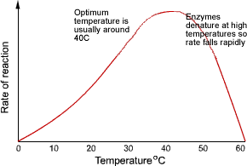
Temperature

Enzymes have an optimum temperature at which they work fastest. For mammalian enzymes this is about 40°C, but there are enzymes that work best at very different temperatures, e.g. enzymes from the arctic snow flea work at -10°C, and enzymes from thermophilic bacteria work at 90°C.

Up to the optimum temperature the rate increases geometrically with temperature (i.e. it's a curve, not a straight
line). The rate increases because the enzyme and substrate molecules both have more kinetic energy and so collide more often, and also because more molecules have sufficient energy to overcome the activation energy.
Above the optimum temperature the rate decreases as more of the enzyme molecules denature. The thermal energy breaks the hydrogen bonds holding the secondary and tertiary structure of the enzyme together, so the enzyme loses its shape and becomes a random coil - and the substrate can no longer fit into the active site. This is irreversible. Remember that only the hydrogen bonds are broken at normal temperatures; to break the primary structure ( the peptide bonds) you need to boil in strong acid for several hours – or use a protease enzyme!
The increase in rate with temperature can be quantified as the Q₁₀, which is the relative increase for a 10°C rise in temperature. Q₁₀ is usually around 2 for enzyme-catalysed reactions (i.e. the rate doubles every 10°C) and usually less than 2 for non-enzyme reactions.

The rate is not zero at 0°C, so enzymes still work in the fridge (and food still goes off), but they work slowly. Enzymes can even work in ice, though the rate is extremely slow due to the very slow diffusion of enzyme and substrate molecules through the ice lattice.

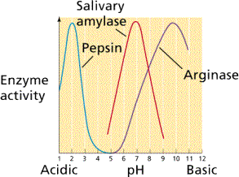
pH

Enzymes have an optimum pH at which they work fastest. For most enzymes this is about pH 7-8 (normal body pH), but a few enzymes can work at extreme pH, such as gastric protease (pepsin) in our stomach, which has an optimum of pH 1.
The pH affects the charge of the amino acids at the active site, so the properties of the active site change and the substrate can no longer bind. For example a carboxyl acid R groups will be uncharged a low pH (COOH), but charged at high pH (COO⁻).

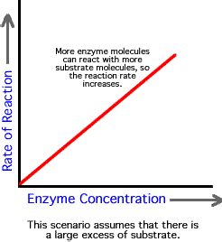
Enzyme concentration

As the enzyme concentration increases the rate of the reaction also increases, because there are more enzyme molecules (and so more active sites), available to catalyse the reaction therefore more enzyme-substrate complexes form. In cells, the substrate is always in excess, so the graph does not level out. In the lab, these conditions need not apply and a plateau can be reached.

4. Substrate concentration
The rate of an enzyme-catalysed reaction is also affected by substrate concentration. As the substrate concentration increases, the rate increases because more substrate molecules can collide with active sites, so more enzyme-substrate complexes form.
At higher concentrations the enzyme molecules become saturated with substrate, and there are few free active sites, so adding more substrate doesn't make much difference (though it will increase the rate of E-S collisions).
The maximum rate at infinite substrate concentration is called v_{max}, and the substrate concentration that gives a rate of half v_{max} is called K_{M}. These quantities are useful for characterising an enzyme. A good enzyme has a high v_{max} and a low K_{M}.

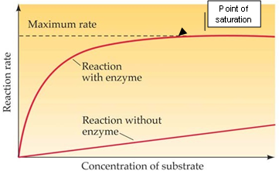

Covalent modification

The activity of some enzymes is controlled by other enzymes, which modify the protein chain by cutting it, or adding a phosphate or methyl group. This modification can turn an inactive enzyme into an active enzyme (or vice versa), and this is used to control many metabolic enzymes and to switch on enzymes in the gut e.g. HCl in stomach → activates pepsin → activates rennin.

Inhibitors

Inhibitors inhibit the activity of enzymes, reducing the rate of their reactions. They are found naturally, but are also used artificially as drugs, pesticides and research tools. There are two kinds of inhibitors.

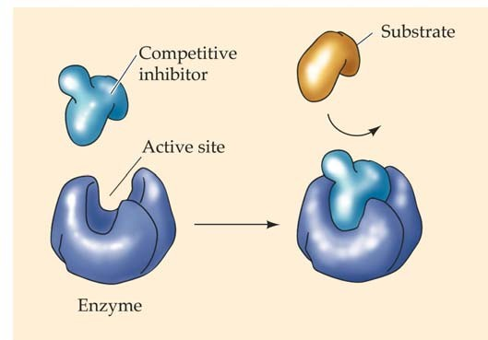
- A competitive inhibitor molecule has a similar structure to the substrate molecule, and so it can fit into the active site of the enzyme. It therefore competes with the substrate for the active site, so the reaction is slower. Increasing the concentration of substrate restores the reaction rate and the inhibition is usually temporary and reversible. Competitive inhibitors increase K_{M} for the enzyme, but have no effect on v_{max}, so the rate can approach a normal rate if the substrate concentration is increased high enough.

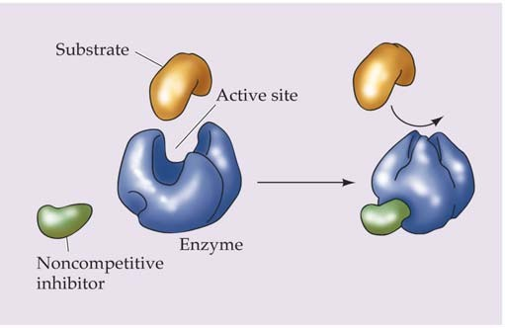
- A non-competitive inhibitor molecule is quite different in structure from the substrate and does not fit into the active site. It binds to another part of the enzyme molecule, changing the shape of the whole enzyme, including the active site, so that it can no longer bind substrate molecules. Non-competitive inhibitors therefore simply reduce the amount of active enzyme. This is the same as decreasing the enzyme concentration, so they decrease v_{max}, but have no effect on K_{M}. This kind of inhibitor tends to bind
tightly and irreversibly – such as the poisons cyanide and heavy metal ions. Many nerve poisons (insecticides) work in this way too.

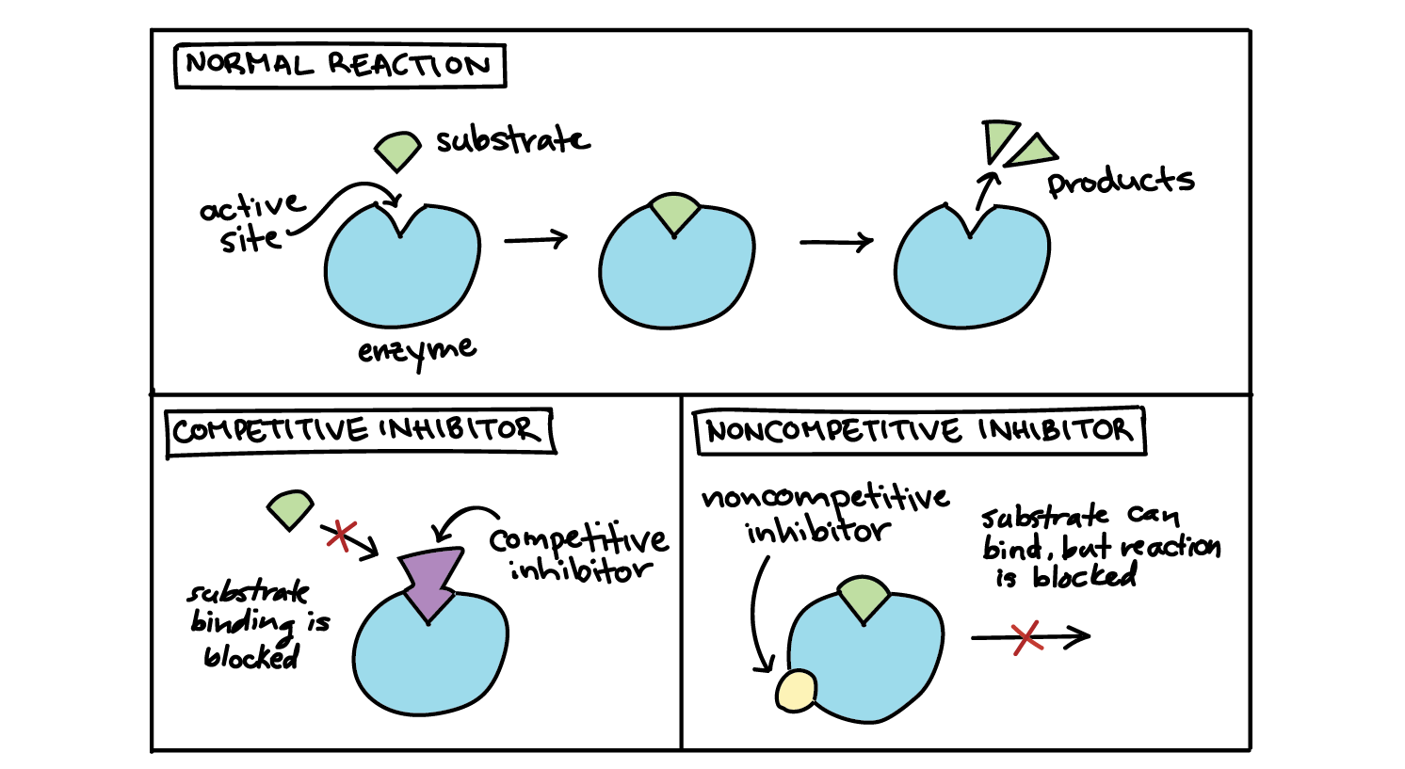

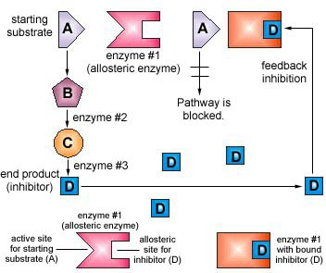
- Feedback Inhibition (Allosteric Effectors)

The activity of some enzymes is controlled by certain molecules binding to a specific regulatory (or allosteric) site on the enzyme, distinct from the active site. Different molecules can either inhibit or activate the enzyme, allowing sophisticated control of the rate. Only a few enzymes can do this, and they are often at the start of a long biochemical pathway. They are generally activated by the substrate of the pathway and inhibited by the product of the pathway, thus only turning the pathway on when it is needed. This process is known as feedback inhibition.

Allosteric enzymes:
Allosteric enzymes are enzymes that have an additional binding site for effector molecules other than the active site. The binding brings about conformational changes, thereby changing its catalytic properties. The effector molecule can be an inhibitor or activator.
All the biological systems are well regulated. There are various regulatory measures in our body, that control all the processes and respond to the various inside and outside environmental changes. Whether it is gene expression, cell division, hormone secretion, metabolism or enzyme activity, everything is regulated to ensure proper development and survival.
Allostery is the process of enzyme regulation, where binding at one site influences the binding at subsequent sites.
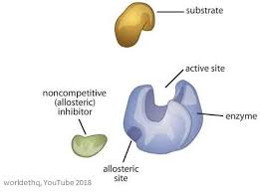

Allosteric Enzyme Properties
- Enzymes are the biological catalyst, which increases the rate of the reaction
- Allosteric enzymes have an additional site, other than the active site or substrate binding site. The substrate-binding site is known as C-subunit and effector binding site is known as R-subunit or regulatory subunit
- There can be more than one allosteric sites present in an enzyme molecule
- They have an ability to respond to multiple conditions, that influence the biological reactions
- The binding molecule is called an effector, it can be inhibitor as well as activator
- The binding of the effector molecule changes the conformation of the enzyme
- Activator increases the activity of an enzyme, whereas inhibitor decreases the activity after binding
- The velocity vs substrate concentration graph of allosteric enzymes is S-curve as compared to the usual hyperbolic curve

