Dr. Rima Kumari: Date: 15/09/2020
Online class and e- content for BSc IIIrd year students
Date and Time | Online class medium | E. content topic
15/09/2020  02:00 p.m to 2.50 p.m | Via Google meet  Link: Meeting URL: https://meet.google.com/mfp-rmtx-rdk | Bacterial Structure

Bacterial Structure

The Cell Wall
The cytoplasm of prokaryotic cells has a high concentration of dissolved solutes. Therefore, the osmotic pressure within the cell is relatively high. The cell wall is a protective layer that surrounds some cells and gives them shape and rigidity. It is located outside the cell membrane and prevents osmotic lysis (bursting due to increasing volume). The chemical composition of the cell walls varies between archaea and bacteria. It also varies between bacterial species.
Bacterial cell walls contain peptidoglycan composed of polysaccharide chains that are cross-linked by unusual peptides containing both L- and D-amino acids, including D-glutamic acid and D-alanine. Proteins normally have only L-amino acids; as a consequence, many of our antibiotics work by mimicking D-amino acids and, therefore, have specific effects on bacterial cell wall development. There are more than 100 different forms of peptidoglycan. S-layer (surface layer) proteins are also present on the outside of cell walls of both archaea and bacteria.
Bacteria are divided into two major groups: gram-positive and gram-negative, based on their reaction to gram staining. Note that all gram-positive bacteria belong to one phylum; bacteria in the other phyla (Proteobacteria, Chlamydias, Spirochetes, Cyanobacteria, and others) are gram-negative. The gram-staining method is named after its inventor, Danish scientist Hans Christian Gram (1853–1938). The different bacterial responses to the staining procedure are ultimately due to cell wall structure. Gram-positive organisms typically lack the outer membrane found in gram-negative organisms. Up to 90 percent of the cell wall in gram-positive bacteria is composed of peptidoglycan, with most of the rest composed of acidic substances called teichoic acids. Teichoic acids may be covalently linked to lipids in the plasma membrane to form lipoteichoic acids. Lipoteichoic acids anchor the cell wall to the cell membrane. Gram-negative bacteria have a relatively thin cell wall composed of a few layers of peptidoglycan (only 10 percent of the total cell wall), surrounded by an outer envelope containing lipopolysaccharides (LPS) and lipoproteins. This outer envelope is sometimes referred to as a second lipid bilayer. The chemistry of this outer envelope is very different, however, from that of the typical lipid bilayer that forms plasma membranes.
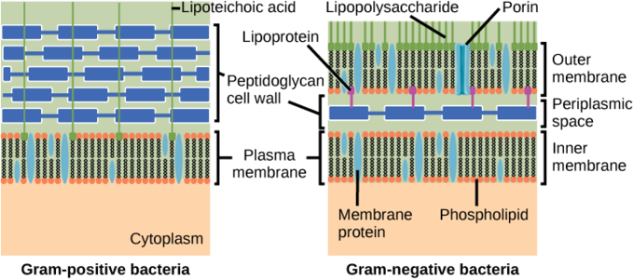
Gram-positive and gram-negative bacteria: Bacteria are divided into two major groups: gram-positive and gram-negative. Both groups have a cell wall composed of peptidoglycan: in gram-positive bacteria, the wall is thick, whereas in gram-negative bacteria, the wall is thin. In gram-negative bacteria, the cell wall is surrounded by an outer membrane that contains lipopolysaccharides and lipoproteins. Porins, proteins in this cell membrane, allow substances to pass through the outer membrane of gram-negative bacteria. In gram-positive bacteria, lipoteichoic acid anchors the cell wall to the cell membrane.

The Plasma Membrane
The plasma membrane is a thin lipid bilayer (6 to 8 nanometers) that completely surrounds the cell and separates the inside from the outside. Its selectively-permeable nature keeps ions, proteins, and other molecules within the cell, preventing them from diffusing into the extracellular environment, while other molecules may move through the membrane. The general structure of a cell membrane is a phospholipid bilayer composed of two layers of lipid molecules. In archaeal cell membranes, isoprene (phytanyl) chains linked to glycerol replace the fatty acids linked to glycerol in bacterial membranes. Some archaeal membranes are lipid monolayers instead of bilayers.
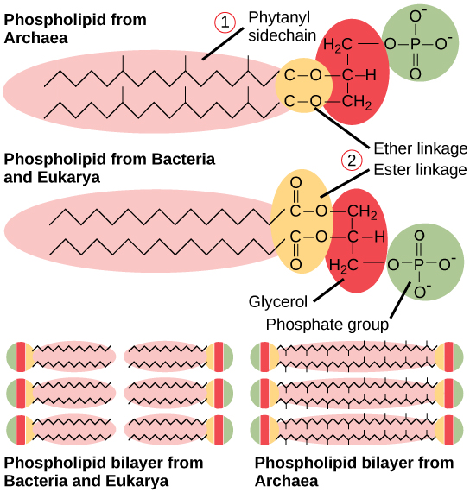
Plasma membrane structure: Archaeal phospholipids differ from those found in Bacteria and Eukarya in two ways. First, they have branched phytanyl sidechains instead of linear ones. Second, an ether bond instead of an ester bond connects the lipid to the glycerol.

Nucleid:
The nucleoid (meaning nucleus-like) is an irregularly-shaped region within the cell of a prokaryote that contains all or most of the genetic material. In contrast to the nucleus of a eukaryotic cell, it is not surrounded by a nuclear membrane. The genome of prokaryotic organisms generally is a circular, double-stranded piece of DNA, of which multiple copies may exist at any time. The length of a genome varies widely, but is generally at least a few million base pairs.
The nucleoid can be clearly visualized on an electron micrograph at high magnification, where it is clearly visible against the cytosol. Sometimes even strands of what is thought to be DNA are visible. The nucleoid can also be seen under a light microscope.by staining it with the Feulgen stain, which specifically stains DNA. The DNA-intercalating stains DAPI and ethidium bromide are widely used for fluorescence microscopy of nucleoids.
Experimental evidence suggests that the nucleoid is largely composed of about 60% DNA, plus a small amount of RNA and protein. The latter two constituents are likely to be mainly messenger RNA and the transcription factor proteins found regulating the bacterial genome. Proteins helping to maintain the supercoiled structure of the nucleic acid are known as nucleoid proteins or nucleoid-associated proteins, and are distinct from histones of eukaryotic nuclei. In contrast to histones, the DNA-binding proteins of the nucleoid do not form nucleosomes, in which DNA is wrapped around a protein core. Instead, these proteins often use other mechanisms, such as DNA looping, to promote compaction.
The Genophore
A genophore is the DNA of a prokaryote. It is commonly referred to as a prokaryotic chromosome. The term “chromosome” is misleading, because the genophore lacks chromatin. The genophore is compacted through a mechanism known as supercoiling, but a chromosome is additionally compacted through the use of chromatin. The genophore is circular in most prokaryotes, and linear in very few. The circular nature of the genophore allows replication to occur without telomeres. Genophores are generally of a much smaller size than Eukaryotic chromosomes. A genophore can be as small as 580,073 base pairs (Mycoplasma genitalium). Many eukaryotes (such as plants and animals) carry genophores in organelles such as mitochondria and chloroplasts. These organelles are very similar to true prokaryotes.

