Dr. Rima Kumari: Date: 27/07/2020
Online class and e- content for M.Sc. IInd year students

Date and Time | Online class medium | E. content topic
27/07/2020  01:40 p.m to 2.30 p.m | Via Google meet  Link: Meeting URL: https://meet.google.com/xyg-mhbq-srg | Plant Tissue culture, tools and techniques used, anther culture, callus culture

Chapter: Plant Tissue culture
Plant Tissue culture is the in vitro (in glass vessels, in laboratory) culture of cells, tissues, organs or whole plant under aseptic condition, controlled nutritional and environmental conditions often to produce the clones of plants. The resultant clones are true-to-type of the selected genotype. An explant (cell tissue, organ or any plant part) used to initiate in vitro culture e.g. shoot tip, leaf, petiole etc.) to generate entire plant. The resultant plants are clone type of the selected genotype. In commercial purpose, tissue culture is primarily used for plant propagation and is often referred to as micropropagation.
Aseptic conditions (sterile; free from microorganisms), controlled environment (uniform temperature, humidity, light duration etc.), a specific culture medium (which provides nutrient for plant growth and usually contains one or more plant growth regulators) maintained in tissue culture. The appropriate composition of organic and inorganic nutrients in culture medium largely determines the success of the culture. The culture media used for the in vitro cultivation of the plant cells are composed of three basic components i) Essential elements supplied as a complex mixture of salts. ii) An organic supplements providing vitamins and amino acids. Usually sucrose supplied as fixed carbon source.
Tissue culture techniques are used for production of disease-free plants, genetic manipulation, plant improvement, producing high yield crop, mass multiplication of desired plant and basic research purpose.

Basics of Plant Tissue Culture:
- G. Haberlandt, a German botanist, in 1902 cultured fully differentiated plant cells isolated from different plants. This was the very first step for the beginning of plant cell and tissue culture. Further contributions were made by the Cell Doctrine which admitted that a cell is capable of showing totipotency.
- The first plant from a mature plant cell was regenerated by Braun in 1959. Foundation of commercial plant tissue culture was laid in 1960 with the discovery for a million fold multiplication of Cymbidium (an orchid) which was accomplished by G.M.Morel. Then after the development of a reliable artificial medium by Murashige & Skoog, 1962, that plant tissue culture really ‘took off’ at commercial level.
- In India, the work on tissue culture was initiated by P.Maheshwari (Delhi University) after discovery of haploid production of plants by in-vitro culturing.
- Shri S.C. Maheshwari and Sipra Guha made a remarkable contribution in the development of plant tissue culture in India.
- G. Haberlandt was the first person who developed the concept of in-vitro culture of plant cells and is aptly regarded as the father of tissue culture.

Principles of Plant Tissue Culture
The basic concept of the plant tissue culture is to produce a higher number of plants that are genetically similar to a parent plant. For this purpose “explant” (small dissected part of plant) is used for tissue culture to develop it into a whole plant. This technique is effective because almost most of the plants cell are totipotent (having ability to generate into whole plant) as each cell possesses the genetic information and cellular machinery necessary to generate the whole organism.
So on, basic principles of Plant tissue culture relies on these facts:
- Totipotency: Many plant cells have the ability to regenerate a whole plant (totipotency). Single cells, plant cells without cell walls (protoplasts), pieces of leaves, stems or roots can often be used to generate a new plant on culture media given the required nutrients and plant hormones. Totipotency forms the basis of successful plant tissue culture. The theory of Totipotency states that each cell has the ability to regenerate into a complete plant. Each somatic cell has the same genetic constitution (DNA sequence) as that of a zygote, and hence, also has the potential of expressing all the properties of an organism. Single cells, plant cells without cell walls (protoplasts), pieces of leaves, stems or roots can often be used to generate a new plant on culture media given the required nutrients and plant hormones. Since, handling a single cell is practically difficult, therefore, usually a tissue or an organ form the plant is used to initiate the tissue culture work and hence Plant Tissue Culture is often also called as Plant Cell, Tissue and Organ Culture.
- Cell plasticity: Plants, due to its longer life span and sessile nature, have developed a greater ability to adapt and overcome the extreme conditions (environmental and biotic). This empowers the plant development and their growth. When the plant cells and tissues are cultured in vitro, most of them are generally exhibit a very high degree of plasticity, which allows one type of organ or tissue to be initiated from another type. Like this way, the whole plant can be subsequently regenerated.
- Optimum environment and nutrient condition: The controlled conditions provide the culture an optimum environment condition for their growth and multiplication. These conditions include the proper supply of nutrients, pH medium, adequate temperature, and proper gaseous and liquid environment.

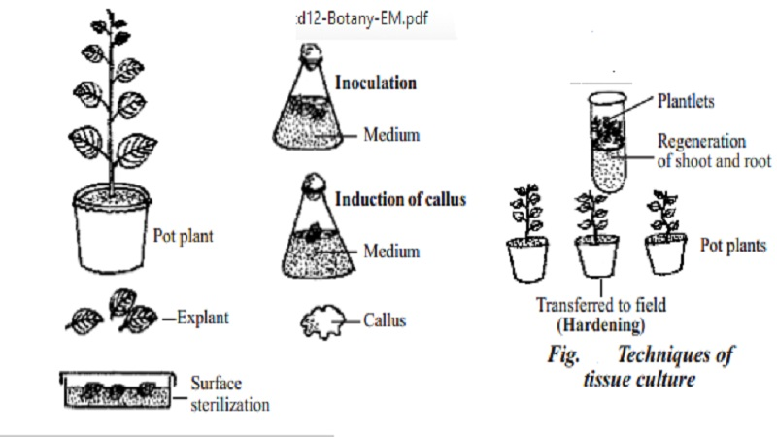
Plant tissue culture
Applications and Advantages of Plant Tissue Culture
- Plant tissue culture technology is being widely used for large scale production of specific plant type.
- Small pieces of tissue (named explants) can be used to produce hundreds and thousands of plants in a continuous process. A single explant can be multiplied into several thousand plants in the relatively short time period and space under controlled conditions, irrespective of the season and weather on a year-round basis.
- Apart from their use as a tool of research, plant tissue culture techniques have in recent years, become of major industrial importance in the area of plant propagation, disease elimination, plant improvement and production of secondary metabolites.
- Endangered, threatened and rare species have successfully been grown and conserved by micropropagation because of high coefficient of multiplication and small demands on the number of initial plants and space.
- In addition, plant tissue culture is considered to be the most efficient technology for crop improvement by the production of somaclonal and gametoclonal variants.
- The micropropagation technology has a vast potential to produce plants of superior quality, isolation of useful variants in well-adapted high yielding genotypes with better disease resistance and stress tolerance capacities
- Alongwith, plant tissue culture has become of great interest to the molecular biologists, plant breeders and even to the industrialists, as it helps in improving the plants of economic importance. In addition to all this, the tissue culture contributes immensely for understanding the patterns and responsible factors of growth, metabolism, morphogenesis and differentiation of plants.
Plant Tissue Culture Technique
- Preparation of plant tissue for tissue culture is performed under aseptic conditions under HEPA filtered air provided by a laminar flow cabinet.
- The tissue is grown in sterile containers, such as Petri dishes or flasks in a growth room with controlled temperature and light intensity.
- Living plant materials from the environment are naturally contaminated on their surfaces (and sometimes interiors) with microorganisms, so their surfaces are sterilized in chemical solutions (usually alcohol and sodium or calcium hypochlorite) before suitable samples (known as explants) are taken.
- The sterile explants are then usually placed on the surface of a sterile solid culture medium but are sometimes placed directly into a sterile liquid medium, particularly when cell suspension cultures are desired.
- Solid and liquid media are generally composed of inorganic salts plus a few organic nutrients, vitamins and plant hormones. Solid media are prepared from liquid media with the addition of a gelling agent, usually purified agar.
- The composition of the medium, particularly the plant hormones and the nitrogen source (nitrate versus ammonium salts or amino acids) have profound effects on the morphology of the tissues that grow from the initial explant.
- For example, an excess of auxin will often result in a proliferation of roots, while an excess of cytokinin may yield shoots.
- A balance of both auxin and cytokinin will often produce an unorganized growth of cells or callus, but the morphology of the outgrowth will depend on the plant species as well as the medium composition.
- As cultures grow, pieces are typically sliced off and subcultured onto new media to allow for growth or to alter the morphology of the culture. The skill and experience of the tissue culturist are important in judging which pieces to culture and which to discard.
- As shoots emerge from culture, they may be sliced off and rooted with auxin to produce plantlets which, when mature, can be transferred to potting soil for further growth in the greenhouse as normal plants.
Experiments on Plant Tissue culture:
1. Preparation of media:
In general, each medium contain five distinct categories of ingredients viz. macro-elements, micro-elements, chelated iron, phytohormones (auxin and cytokine) and plant organics. Usually the stock solution way prepared earlier and stored in refrigerator. When required, these stock solutions were mixed together in proportions for preparation of an artificial culture medium (Murashige and Skoog (MS) Medium.

2. Laboratory equipment’s and goods:
(i) pH meter
ii) Autoclave : Autoclave is used to sterilize medium, glassware and tools for the purpose of plant tissue culture. Sterilization of material is carried out by increasing moist heat (121 °C) due to increased pressure inside the vessel (15-22 psi, pounds per square inch or 1.02 to 1.5 kg/cm²) for 15 minutes for routine sterilization. Moist heat kills the microorganism and makes the material free from microbes.
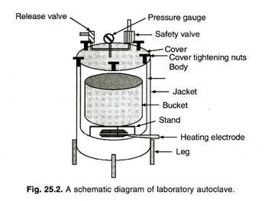
3. Plant Growth Chamber:
Plant growth chambers can be constructed in a suitable sized room or can be purchased as commercially available equipment. Thermal insulation of walls increases the efficiency of the cooling system.
Essentially plant growth chamber has three environmental control systems:
1. Light-intensity and duration cycle control.
2. Temperature control and regulation.
3. Humidity control and regulation.

Laminar Air Flow Bench:
Laminar air flow (LAF) bench is the main working table for aseptic manipulations related to plant tissue culture. This is equipment fitted with High Efficiency Particulate Air (HEPA) Filters, which allow air to pass but retain all the particles and micro-organisms. These HEPA Filters have a very small pore size (0.3 µm) with 99.97-99.99% efficiency.
Air blown by a blower is passed through these filters, thus, always generally a positive pressure of air is maintained from inside to outside. This positive pressure does not allow any particle to enter in the working area of LAF bench. Air pressure inside the instrument is measured by a manometer and pressure of more than 12 bars shows choking of filters and at this point filters should be replaced. Equipment is fitted with UV light and visible light source.
UV is switched-on for 30 minutes before starting the work to make area free from microbes. LAF Bench of steel and wooden cabinets is available with different working table size and for vertical (downward air flow) or horizontal (horizontal flow) model. There are several manufacturers in India for this instrument (body) but HEPA filters are imported. HEPA filters are also used to create ‘clean area’ for culture rooms and inoculation room etc. If LAF bench is placed in such a clear area, efficiency and life of the equipment are increased.
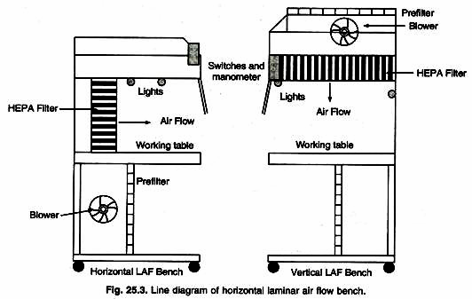

5. Microscopy:
All the modern instruments are electronically controlled precision instruments with sophisticated sensors and timers to regulate the desired set values.
Culture tubes, Tissue paper, Petridishes, Aluminium foil, Forceps, Scalpels, Distilled water,
General technique of aseptic manipulation:
The following points highlight the five main steps for aseptic manipulation.
The steps are: 1. Sterilisation of the Culture Vessels and Instruments
2. Sterilisation of Nutrient Media
3. Sterilisation of Culture Rooms and Transfer-Area
4. Sterilisation of Explant
5. Aseptic Transfer of Explant/Sub-Culturing.

Step 1. Sterilisation of the Culture Vessels and Instruments:
For sterilisation of culture vessels, glassware’s, instruments, etc. it is better to use steam sterilisation techniques i.e., by autoclaving at high pressure (15 pound/inch²) and high temperature (121°C) for 15-20 mins. All the items should be properly covered with aluminium foil before sterilisation. Glassware’s, metal instruments can also be sterilised by exposure to dry hot air oven (160°-180°C) for 2-4 hrs.
Plastic labware of special types, cotton plugs, gauze, filters can be sterilised using steam sterilisation technique. The autoclaved instruments like forceps, scalpels, needles, spatula are further sterilised by flame sterilisation technique before use by dipping in 95% alcohol, and followed by flaming and cooling.

Step # 2. Sterilisation of Nutrient Media:
The nutrient media used in tissue culture are commonly sterilised by autoclaving and filter sterilisation. Macro-, micronutrients and other stable compound mixtures are autoclaved, whereas the thermolabile compounds are filter-sterilised separately and mixed with the media whenever necessary. Culture media containing high conc. of sugars when autoclaved the carbohydrates get decomposed under high pressure.
Some vitamins, amino acids, plant extracts and hormones are thermolabile, they require filter sterilisation. The solutions are passed through a bacterial membrane filter under pressure (pore size 0.2 µm), the sterilised solution is then mixed separately with autoclaved media.

Step # 3. Sterilisation of Culture Rooms and Transfer-Area:
The floor and walls of culture rooms are cleaned by gently washing with detergent then by wiping them with 2% sodium hypochlorite solution and then using ethanol. Commercially available disinfectants like Lysol can be used for this purpose. The process of surface sterilisation of culture rooms should be done at regular intervals.
The transfer-area is also sterilised once or twice a month by washing with common brand of antifungal agent. Transfer rooms or areas are further sterilised by UV light. UV radiation is harmful for eyes, so UV radiation should be done before operation.
Where laminar air flow cabinet is used for transfer, the surface is cleaned by ethanol and chamber is sterilised by UV light before work in progress. Then the sterile air is flowed through HEPA filter during works.

Step # 4. Sterilisation of Explant:
All different kinds of plant materials or explants should be surface sterilised by a variety of chemicals before using in tissue culture (Fig. 16.3). It is the eradication of surface microorganisms with the help of different chemicals. The type and concentration of different chemical sterilant to be used for sterilisation of different types of explants and exposure time must be decided experimentally.
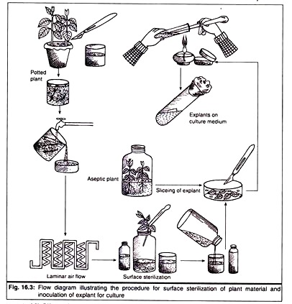
Sometimes the sterilisation procedure may lead to lethality to plant tissue, so the use of disinfectants should be tested. Here are few disinfectants which are used commonly for surface sterilisation of different explants (Table 16.2).
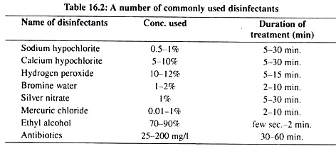
(a) 1% solution of Sodium hypochlorite (NaClO), commercial bleach having 5% active chlorine can be used.
(b) 4%-l0% solution of Calcium hypochlorite [Ca(ClO)₂] can be used, it enters within the plant tissue slower than sodium hypochlorite.
(c) 1% solution of Bromine-water.
(d) 0.01-0.1% solution of Mercuric Chloride (HgCl₂) which is an extremely toxic substance for plant tissue, repeated rinsing with water is very much essential.
(e) 70% Ethyl alcohol is used for sterilisation of plant material dipping them for 30 sec-2 mins.
(f) 10% Hydrogen peroxide (H₂O₂) solution is effective for end surface sterilisation.
All these sterilants should be washed out properly before using the explant as the retention of these chemical substances may affect the establishment of successful tissue culture. But in most of the cases it becomes difficult to determine the optimal conditions for each kind of tissue.
So to avoid this problem the explants can be taken from aseptically grown plants developed from the surface sterilised seeds as these seeds are more resistant to chemicals due to presence of seed coat.
or this purpose, the seeds are surface sterilised and then cultured aseptically in basal nutrient media. These give rise to aseptic seedlings from which the different explants can be used. Explants from such seedlings need no further sterilisation.
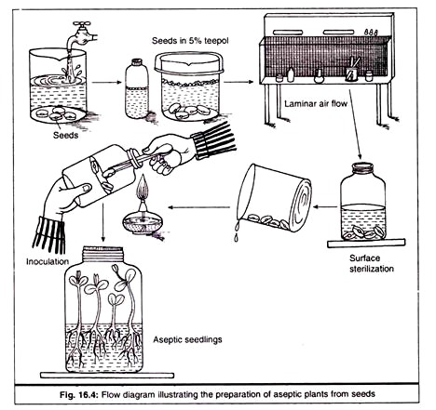
But for another culture and shoot tip culture the explants are collected from outside grown plant. For these kinds of explants addition of few drops of surfactant (Trito-X or Tween-20) to the solution or treating the plant material in a solution of Cetavlon for 2 min. before exposing to sterilant may enhance sterilisation efficiency.

Step # 5. Aseptic Transfer of Explant/Sub-Culturing:
Control of contamination largely depends upon the operator’s technique while transferring the sterilised explant/sub-culturing into the sterile culture vial containing nutrient media under aseptic condition. Dust from the surface, hair, hands and clothes are the potential sources of contamination.
Before starting the transfer procedure the surface of transfer area and hands should wiped with 95% ethanol; sterile clothes (aprons) should be used. All the metallic equipment’s used for transfer (inoculating needle, forceps, scalpel) should be dipped into 95% ethanol and then flamed and cooled. The tissue material should not touch the edge of culture vessel during transfer

Composition of culture media and its preparation:
Culture media are largely responsible for the in vitro growth and morphogenesis of plant tissues. The success of the plant tissue culture depends on the choice of the nutrient medium. In fact, the cells of most plant cells can be grown in culture media. Basically, the plant tissue culture media should contain the same nutrients as required by the whole plant. It may be noted that plants in nature can synthesize their own food material. However, plants growing in vitro are mainly heterotrophic i.e. they cannot synthesize their own food.
Synthetic and natural media:
When a medium is composed of chemically defined components, it is referred to as a synthetic medium. On the other hand, if a medium contains chemically undefined compounds (e.g., vegetable extract, fruit juice, plant extract), it is regarded as a natural medium. Synthetic media have almost replaced the natural media for tissue culture.
Composition of Media:
The composition of the culture media is primarily dependent on two parameters:
1. The particular species of the plant.
2. The type of material used for culture i.e. cells, tissues, organs, protoplasts.
Thus, the composition of a medium is formulated considering the specific requirements of a given culture system. The media used may be solid (solid medium) or liquid (liquid medium) in nature. The selection of solid or liquid medium is dependent on the better response of a culture.
The culture media usually contain the following constituents:
1. Inorganic nutrients
2. Carbon and energy sources
3. Organic supplements
4. Growth regulators
5. Solidifying agents
6. pH of medium

Inorganic Nutrients:
The inorganic nutrients consist of macronutrients (concentration >0.5 mmol/l–) and micronutrients (concentration <0.5 mmol/l–). A wide range of mineral salts (elements) supply the macro- and micronutrients. The inorganic salts in water undergo dissociation and ionization. Consequently, one type of ion may be contributed by more than one salt. For instance, in MS medium, K⁺ ions are contributed by KNO₃ and KH₂PO₄ while NO₃– ions come from KNO₃ and NH₄NO₃.
Macronutrient elements:
The six elements namely nitrogen, phosphorus, potassium, calcium, magnesium and sulfur are the essential macronutrients for tissue culture. The ideal concentration of nitrogen and potassium is around 25 mmol I⁻¹ while for calcium, phosphorus, sulfur and magnesium, it is in the range of 1-3 mmol I–. For the supply of nitrogen in the medium, nitrates and ammonium salts are together used.
Micronutrients:
Although their requirement is in minute quantities, micronutrients are essential for plant cells and tissues. These include iron, manganese, zinc, boron, copper and molybdenum. Among the microelements, iron requirement is very critical. Chelated forms of iron and copper are commonly used in culture media.

Carbon and Energy Sources:
Plant cells and tissues in the culture medium are heterotrophic and therefore, are dependent on the external carbon for energy. Among the energy sources, sucrose is the most preferred. During the course of sterilization (by autoclaving) of the medium, sucrose gets hydrolysed to glucose and fructose.
The plant cells in culture first utilize glucose and then fructose. In fact, glucose or fructose can be directly used in the culture media. It may be noted that for energy supply, glucose is as efficient as sucrose while fructose is less efficient.
It is a common observation that cultures grow better on a medium with autoclaved sucrose than on a medium with filter-sterilized sucrose. This clearly indicates that the hydrolysed products of sucrose (particularly glucose) are efficient sources of energy. Direct use of fructose in the medium subjected to autoclaving, is found to be detrimental to the growth of plant cells. Besides sucrose and glucose, other carbohydrates such as lactose, maltose, galactose, raffinose, trehalose and cellobiose have been used in culture media but with a very limited success.

Organic Supplements:
The organic supplements include vitamins, amino acids, organic acids, organic extracts, activated charcoal and antibiotics.
Vitamins:
Plant cells and tissues in culture (like the natural plants) are capable of synthesizing vitamins but in suboptimal quantities, inadequate to support growth. Therefore the medium should be supplemented with vitamins to achieve good growth of cells. The vitamins added to the media include thiamine, riboflavin, niacin, pyridoxine, folic acid, pantothenic acid, biotin, ascorbic acid, myoinositol, Para amino benzoic acid and vitamin E.
Amino acids:
Although the cultured plant cells can synthesize amino acids to a certain extent, media supplemented with amino acids stimulate cell growth and help in establishment of cells lines. Further, organic nitrogen (in the form of amino acids such as L-glutamine, L-asparagine, L- arginine, L-cysteine) is more readily taken up than inorganic nitrogen by the plant cells.
Organic acids:
Addition of Krebs cycle intermediates such as citrate, malate, succinate or fumarate allow the growth of plant cells. Pyruvate also enhances the growth of cultured cells.
Organic extracts:
It has been a practice to supplement culture media with organic extracts such as yeast, casein hydrolysate, coconut milk, orange juice, tomato juice and potato extract. It is however, preferable to avoid the use of natural extracts due to high variations in the quality and quantity of growth promoting factors in them. In recent years, natural extracts have been replaced by specific organic compounds e.g., replacement of yeast extract by L-asparagine; replacement of fruit extracts by L-glutamine.
Activated charcoal:
Supplementation of the medium with activated charcoal stimulates the growth and differentiation of certain plant cells (carrot, tomato, orchids). Some toxic/inhibitory compounds (e.g. phenols) produced by cultured plants are removed (by adsorption) by activated charcoal, and this facilitates efficient cell growth in cultures. Addition of activated charcoal to certain cultures (tobacco, soybean) is found to be inhibitory, probably due to adsorption of growth stimulants such as phytohormones.
Antibiotics:
It is sometimes necessary to add antibiotics to the medium to prevent the growth of microorganisms. For this purpose, low concentrations of streptomycin or kanamycin are used. As far as possible, addition of antibiotics to the medium is avoided as they have an inhibitory influence on the cell growth.

Growth Regulators:
Plant hormones or phytohormones are a group of natural organic compounds that promote growth, development and differentiation of plants. Four broad classes of growth regulators or hormones are used for culture of plant cells-auxins, cytokinins, gibberellins (Fig. 43.1) and abscisic acid. They promote growth, differentiation and organogenesis of plant tissues in cultures.
Auxins:
Auxins induce cell division, cell elongation, and formation of callus in cultures. At a low concentration, auxins promote root formation while at a high concentration callus formation occurs. A selected list of auxins used in tissue cultures is given in Table 43.3.
Among the auxins, 2, 4-dichlorophenoxy acetic acid is most effective and is widely used in culture media.
Cytokinins:
Chemically, cytokinins are derivatives of a purine namely adenine. These adenine derivatives are involved in cell division, shoot differentiation and somatic embryo formation. Cytokinins promote RNA synthesis and thus stimulate protein and enzyme activities in tissues. The most commonly used cytokinins are given in Table 43.3. Among the cytokinins, kinetin and benzyl-amino purine are frequently used in culture media.
Gibberellins:
About 20 different gibberellins have been identified as growth regulators. Of these, gibberellin A₃ (GA₃) is the most commonly used for tissue culture. GA₃ promotes growth of cultured cells, enhances callus growth and induces dwarf plantlets to elongate. Gibberellins are capable of promoting or inhibiting tissue cultures, depending on the plant species. They usually inhibit adventitious root and shoot formation.
Abscisic acid (ABA):
The callus growth of cultures may be stimulated or inhibited by ABA. This largely depends on the nature of the plant species. Abscisic acid is an important growth regulation for induction of embryogenesis.

Solidifying Agents:
For the preparation of semisolid or solid tissue culture media, solidifying or gelling agents are required. In fact, solidifying agents extend support to tissues growing in the static conditions.
Agar:
Agar, a polysaccharide obtained from seaweeds, is most commonly used as a gelling agent for the following reasons.
1. It does not react with media constituents.
2. It is not digested by plant enzymes and is stable at culture temperature.
Agar at a concentration of 0.5 to 1% in the medium can form a gel.
Gelatin:
It is used at a high concentration (10%) with a limited success. This is mainly because gelatin melts at low temperature (25°C), and consequently the gelling property is lost.
Other gelling agents:
Bio-gel (polyacrylamide pellets), phytagel, gelrite and purified agarose are other solidifying agents, although less frequently used. It is in fact advantageous to use synthetic gelling compounds, since they can form gels at a relatively low concentration (1.0 to 2.5 g l⁻¹).

pH of medium:
The optimal pH for most tissue cultures is in the range of 5.0-6.0. The pH generally falls by 0.3-0.5 units after autoclaving. Before sterilization, pH can be adjusted to the required optimal level while preparing the medium. It is usually not necessary to use buffers for the pH maintenance of culture media.
At a pH higher than 7.0 and lower than 4.5, the plant cells stop growing in cultures. If the pH falls during the plant tissue culture, then fresh medium should be prepared. In general, pH above 6.0 gives the medium hard appearance, while pH below 5.0 does not allow gelling of the medium.

Callus culture:
The callus culture from excised carrot tap root is described here as a type case:
1. A fresh tap root of carrot is taken and thoroughly washed under running tap-water to remove all surface debris;
2. The root is then dipped into 5% Teepol for 5 to 10 minutes for surface sterilization and then the root is washed in sterilized distilled water;
3. The root is further surface sterilized by immersing in 70% ethanol (v/v) for 40-60 seconds, followed by 5% sodium hypo-chloride (v/v) for 20-30 minutes;
4. The root is finally washed in sterilized distilled water (three times);
5. Then with the help of sterilized scalpel, a thin section of root is made aseptically on a sterilized petridish, which was subsequently immersed in 5% sodium hypochlorite solution for 5-10 minutes and finally washed by sterilized distilled water and placed in a series on a sterilized petridish;
6. Then carefully cambial tissue explant was removed aseptically from the slices and then quickly transfer the same into medium, for callus growth;
7. The process of inoculation of medium by sterilized tissue explants and subsequent incubation is very much identical to the microbial isolation and incubation technique.
8. At least after 4-6 weeks, callus growth can be notices on the edge of tissue explant thus implanted on desired medium;
9. Then callus tissue was removed from the culture tube and segmented aseptically for subsequent subculture of callus. Prolong culture of callus will produce large mass of callus which is either used for regeneration organogenesis or commercial extraction of secondary metabolites.
Detailed stages of callus culture procedure from carrot root is given in Fig. 1.1.
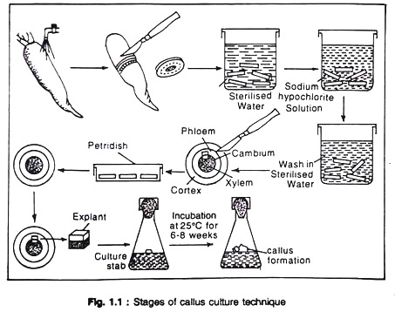
Anther Culture and the Establishment of Haploid Plants:
This is a technique by which immature pollen is made to divide and grow into tissue (either callus or embryonic tissue), primarily to produce haploids (plants with an N chromosome number) known to be anther culture. Datura stramonium was the first haploid plant that was discovered by Bergner in 1921. But Successful anther culture was first reported in the 1970s through in vitro methods by Guha and Maheshwari. The advantages include a high frequency of haploid plants, easy to induce cell division in most species, and no requirement of a high level of expertise. It involves selecting suitable parents in a breeding program depending on the goals and conducting a cross. In this culture Anthers may be removed aseptically from sterilized flower buds and placed in culture. A proportion of pollen within these anthers — particularly those from Solanaceous species — grow and proceed through a series of developmental stages, eventually giving rise to haploid embryos.
This phenomenon has been designated as “androgenesis”. In addition, there is also possibilities of haploid embryo formation, the ultimate resultant is the formation of regenerated haploid plant.
Materials and Methods:
1. Flower buds (freshly collected) of Nicotiana tabacum;
2. Modified Ms culture media;
3. Sterilized glass goods like petridish, beakers, glass vial with lids;
4. Sterilized scalpel, forceps, Bunsen burner etc.;
5. Surface stimulants like 5% teepol, 70% ethanol (v/v), sterilized distilled water.
Procedure
The steps of anther culture are:
1. The flower buds of Nicotiana tubacum (measuring 15-20 mm), is collected from flowering plants only;
2. Then selected buds are taken for surface sterilization by immersing in 5% teepol solution for 40-60 seconds. The buds are immediately washed in sterilized distilled water;
3. Subsequently, the buds are immersed in 70% ethanol (v/v) for 10 seconds followed by 2% sodium hypochlorite (v/v) for 10 minutes. Finally, the buds were washed thoroughly in sterilized distilled water (three times) and transferred to pre-sterilised petridishes;
4. By sterile forceps and scalpel, the anthers were aseptically removed and then either anthers are directly placed on culture media aseptically or they are crushed for isolation of pollen through centrifugation in sterilized buffer and then suspension of pollen is plated on agar media for embryogenesis;
5. The cultures are kept initially in dark. After 3-4 weeks they undergo embryogenesis or androgenesis and then the culture vials are kept in light for proliferation of callus tissues;
6. At this stage, the culture was incubated at 24-28°C for 14 hrs. in light at about 2,000 lux. intensity, then plantlets are regenerated from young differentiated embryo.
The detailed stages of anther culture techniques are shown in Fig 1.2.Stages of anther sulture technique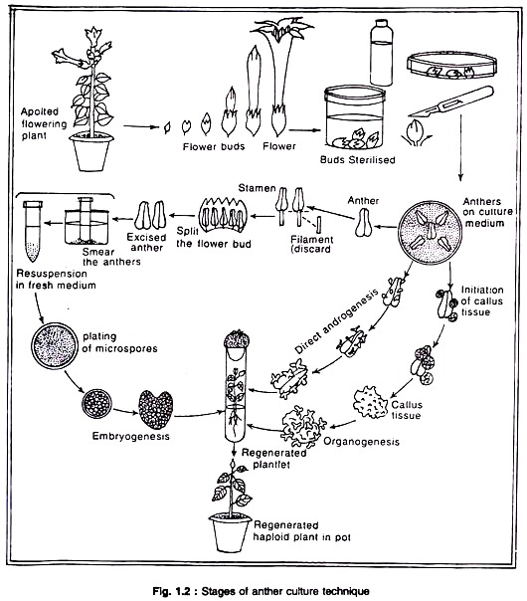

Single Cell Culture?
Single cell culture is a method of growing isolated single plant cell aseptically on a nutrient medium under controlled condition and its development into complete plant.
Technique of Single Cell Culture:
The basic principle of single cell culture is the isolation of large number of intact living cells and cultures them on a suitable nutrient medium for their requisite growth and development. Single cells can be isolated from a variety of tissue and organ of green plant as well as from callus tissue and cell suspension. Single cells from the intact plant tissue (leaf, stem, root cladode etc.) are isolated either mechanically or enzymatically.
Mechanical isolation involves tearing or chopping the surface sterilized explant to expose the cells followed by scraping of the cells with a fine scalpel to liberate the single cells hoping that it remains undamaged. But very few living cells are obtained for a lot of time and effort. Gentle grinding of surface sterilized explant in a sterilized mortar-pestle followed by cleaning the cells by filtration and centrifugation is now widely used for the large-scale mechanical isolation of viable cells.
A considerably more efficient way of large-scale isolation of free cells from the surface sterilized is to dissolve the intercellular cementing material, i.e. pectin, by pectinase or macerozyme treatment. The enzyme macerates the tissue from which large-number of variable cells can be obtained. The special feature of enzymatic isolation of cell is that it has been possible to obtain pure preparation of viable cells with less effort and time.
The single cells are traditionally isolated from the established friable callus tissue and cell suspension culture. Mechanically, single cells are carefully isolated from cell suspension or friable callus with a needle or fine glass capillary. Alternatively, the friable tissue is transferred to liquid medium and the medium is continuously agitated by a shaker.
Agitation of liquid medium breaks and dispenses the single cells and cell clumps in the medium. As a result, it makes a cell suspension. The cell suspension is first filtered to remove cell clumps and the filtrate is then centrifuged to collect the single cells from the pellete.
The isolated single cell can be cultured either in liquid medium or on solid medium. There are five basic methods that are used for culturing single cells such as paper raft nurse technique the petri dish plating technique, the micro-chamber technique, the micro-droplet technique, the plating with nurse tissue technique. In culture, the single cells divide re-divide to form a callus tissue. Such callus tissue also retains the capacity to regenerate the plantlets through organogenesis and embryogenesis.
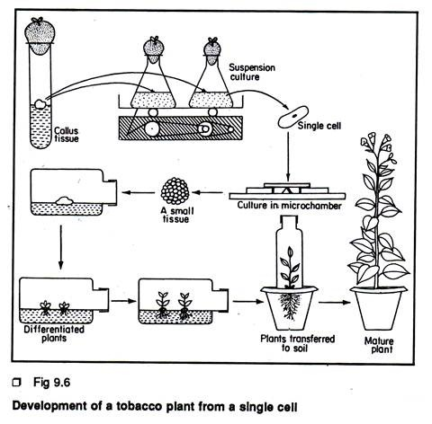
Importance of Single Cell Culture:
Single cell culture technique is very important for the fundamental and mutation studies and it has a wide industrial application.
1. Single cell culture could be used successfully to obtain single cell clones.
2. Plants could be regenerated from the callus tissue derived from the single cell clones

3. The occurrence of high degree of spontaneous variability in the cultured tissue and their exploitation through single cell culture are very important in relation to crop improvement programmes.
4. One of the major problems of mutation breeding in higher plants is the formation of chimeras following the mutagenic treatment of multi-cellular organism. In this respect single cell culture method are more efficient. Isolated single cells can be handled as a microbial system for the treatment of mutagens and for mutant selection. In practice, single cells are grown on a medium containing the mutagenic compounds and the proliferating cell lines are isolated. The mutant nature of the selected cell lines can be confirmed by regenerating the plants and comparing their phenotypes with a normal plant. Many cell lines resistant to ammo acid analogues, antibiotics, herbicides, fungal toxins etc. have been selected by this simplest method.
5. Many plants synthesize various important natural compounds in the form of alkaloids, steroids etc. Some of these natural compounds are highly medicinally important. Several workers have reported the synthesis of several times higher amounts of alkaloid by cell culture than the alkaloid content in the intact plant. So, from the commercial point of view, single cell culture in large-scale could become a valuable technique for industrial production of such important natural compound.
6. Biotransformation means the cellular conversion of an exogenously supplied substrate compound not available in the cell or the precursor of a particular cellular compound to a new compound or the known compounds in higher amounts.
7. Induction of polyploidy has been found to be very useful for plant breeding to overcome the problem of sterility associated with hybrids of unrelated plants. Polyploidy can easily be achieved by single cell culture. A large-number of genetically sterile hybrids exist in the genus Saccharum. When cell culture of such sterile hybrid is treated with 50 mg/L colchicine for 4 days, it has been found that about 48% of such treated cells become uniformly polyploid. These polyploid cells are then induced to regenerate a large-number of fertile plants. In this regard, cell culture is very useful with other crops also.
Important terminologies
Aseptic – The state of being free of contaminating organisms (bacteria, fungi, algae and all micro-organisms except viruses)
Callus – A mass of thin-walled, undifferentiated plant cells, meristematic (high regeneration capacity) in nature. It developed as the result of culture on nutrient media.
Clone –genetically identical plants developed by process of in-vitro tissue culture, vegetative propagation or, without involving sexual process.
Differentiation – A process in which unspecialized cells develop structures and functions characteristic of a particular type of cell. Development from one cell to many cells, accompanied by a modification of the new cells for the performance of particular functions. In tissue culture, the term is used to describe the formation of different cell types.
Excision – Cutting out and preparing a tissue, organ, etc., for culture.
Explant –The excised piece of differentiated tissue or the organ which is used for culture is called as explant (Donar plant) e.g., embryos, young leaf, bud, etc Tissue aseptically obtained and prepared from the donor plant for culture
Hardening off – Adapting plants to outdoor conditions by gradually withholding water, lowering the temperature, increasing light intensity, or reducing the nutrient supply. The hardening-off process conditions plants for survival when transplanted outdoors. The term is also used for gradual acclimatization to in vivo conditions of plants grown in vitro, e.g., gradual decrease in humidity. cf acclimatization; free-living conditions.
Inoculum – A small piece of tissue cut from callus, or an explant from a tissue transferred into fresh medium for continued growth of the culture.
Inositol – C6H6(OH)6, A water-soluble nutrient frequently referred to as a “vitamin” in plant tissue culture.
Meristem – Undifferentiated tissue, the cells of which are capable of active cell division and differentiation into specialized and permanent tissue such as shoots and roots.
In vitro –test tube culture, outside the natural environment, in an artificial environment, typically in glass vessels in which cultured cells, tissues, or whole plants may reside.
In vivo – The natural conditions in which living organism or cell live.
Tissue Culture: The in-vitro culture of the tissue e.g. Callus culture
Organ Culture: This term is used for in-vitro culturing of organs like embryo, root or shoot apices.
Suspension Culture: Defined as the culture of cell and cell aggregates suspended in a liquid medium.
Scarification – The chemical or physical treatment given to some seeds (where the seed coats are very hard or contain germination inhibitors) in order to break or weaken the seed coat sufficiently to permit germination.
Totipotency---A cell characteristic in which it has potential for forming all the cell types and develop in the entire organism.
Viability – The capability to live and develop normally.
Viable – Capable of germinating, living, growing and developing.

