Dr. Rima Kumari: Date: 29/07/2020
Online class and e- content for BSc IIIrd year students

Date and Time | Online class medium | E. content topic
29/07/2020  12:30 p.m to 1.20 p.m | Via Google meet  Link: Meeting URL: https://meet.google.com/dya-tqwh-org | Basic concept of enzyme, Enzyme nature, classification

Enzymes
Enzymes are central to every biochemical reaction within all living cells of an organism and are called the catalysts of biological systems (biocatalysts). They in organized sequences catalyse the hundreds of stepwise reactions by which nutrient molecules are degraded, chemical energy is conserved and transformed, and biological macromolecules are made from simple precursors. Through the action of regulatory enzymes, metabolic pathways are highly coordinated to yield a harmonious interplay among the many different activities necessary to sustain life. Enzymes catalyse an enormous diversity of biochemical reactions due to their capacity to specifically bind a very wide range of molecules. Enzymes bring substrates together in an optimal orientation, to undergo making and breaking chemical bonds. They catalyse reactions by stabilizing transition states, the highest energy-species in reaction pathways. By selectively stabilizing a transition state, an enzyme determines which one of several potential biochemical reactions actually takes place.
Until 1980s, all enzymes were believed to be proteins. Then, Tom Cech and Sidney Altman independently discovered that certain RNA molecules may function as enzymes may be effective biocatalysts. These RNA biocatalysts have come to be known as ribozymes.
Enzymes:
Definition: Enzymes are commonly proteinaceous substances which are capable of catalysing chemical reactions of biological origin without themselves undergoing any change. Therefore, they are called biocatalysts. Enzymes are synthesised by living cells.
The term ‘enzyme’ was coined by Kuhne (1878) for catalytically active substances previously called ferments. Enzymes were actually found out by Buchner (1897) with the accidental discovery that fermentation of sugar is not only caused by living yeast cells but also yeast extract. The extract obviously possessed biocatalysts required for the process. Buchner (1903) also isolated the first enzyme. He was awarded Nobel Prize in the same year, 1903. There are numerous enzymes as every biochemical reaction is catalysed by a separate enzyme. It is estimated that a cell contains over 5000 chemicals. The number of chemical reactions is many times more.
Enzymes functional outside the living cells are called exo-enzymes, e.g., enzymes present in digestive juices, lysozyme of tears. Enzymes functional inside living cells are known as endoenzymes, e.g., enzymes of Krebs cycle (inside mitochondria), enzymes of glycolysis (inside cytoplasm).
Enzymes are mainly functional inside the living cells. As found out by Buchner they can be extracted from the cells and made to catalyse reactions outside the living cells. In nature some enzymes are secreted by living cells and made to perform extracellular catalysis. Digestive enzymes belong to this category. Several enzymes of medical and chemical impor­tance are now available in the market, e.g., rennet tablets (from rennin of calf stomach) for coagulating milk protein casein during preparation of cheese and other milk products.
The biochemical which is acted upon by an enzyme is known as substrate. In case two biochemicals are involved in a reaction, the same are called reactants. The chemicals formed after the completion of a reaction are termed as products. The final products are also called end products. Part of enzyme that takes part in catalysing biochemical reaction is called active site.
The protein nature of enzyme was first discovered by James Sumner in 1926 when he purified the enzyme urease and obtained it in crystalline form. For this, Sumner was awarded Nobel Prize in 1946.

Substrate in active site

Enzyme Structure
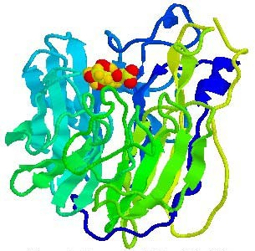
Enzymes are proteins, and their function is determined by their complex structure. The reaction takes place in a small part of the enzyme called the active site, while the rest of the protein acts as "scaffolding". This is shown in this diagram of a molecule of the enzyme trypsin, with a short length of protein being digested in its active site. The amino acids around the active site attach to the substrate molecule and hold it in position while the reaction takes place. This makes the enzyme specific for one reaction only, as other molecules won't fit into the active site – their shape is wrong.

Many enzymes need cofactors (or coenzymes) to work properly. These can be metal ions (such as Fe²⁺, Mg²⁺, Cu²⁺) or organic molecules (such as haem, biotin, FAD, NAD or coenzyme A). Many of these are derived from dietary vitamins, which is why they are so important. The complete active enzyme with its cofactor is called a holoenzyme, while just the protein part without its cofactor is called the apoenzyme.

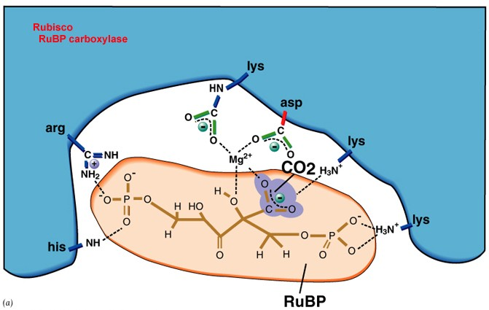
The active site of RUBISCO, the key enzyme in photosynthesis, contains just 6 amino-acids.

Important terminologies:
Holoenzyme and Apoenzyme: An enzyme that requires a helper group and isn't complete without it. Once attached, it's called a holoenzyme. A holoenzyme is an enzyme with any co-factor (metal ions or coenzymes) attached to it that is now ready to catalyze a reaction. An enzyme without a cofactor is called an apoenzyme. An apoenzyme and its cofactor together constitute the holoenzyme.

Cofactors
Cofactors are non-proteinous substances that associate with enzymes. A cofactor is essential for the functioning of an enzyme that increases the rate of reaction. Cofactors are not proteins but rather help enzymes, although they can also help non-enzyme proteins as well.
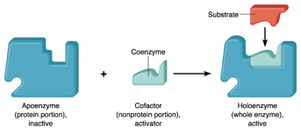
There are three kinds of cofactors present in enzymes:
- Prosthetic groups: These are cofactors tightly bound to an enzyme at all times. A fad is a prosthetic group present in many enzymes.
- Coenzyme: Coenzymes are defined as organic molecules, small, non-protein which are also termed as cosubstrates. They act as carriers. coenzyme is bound to an enzyme only during catalysis. At all other times, it is detached from the enzyme. Some examples of coenzymes are vitamin-b, coenzyme A, biotin, NAD⁺ etc.
- Metal ions: For the catalysis of certain enzymes, a metal ion is required at the active site to form coordinate bonds. Iron and Zn²⁺ is a metal ion cofactor used by a number of enzymes.

Coenzymes
A specific type of cofactor, coenzymes, are organic molecules that bind to enzymes and help them function. The key here is that they're organic. Organic molecules are simply molecules that contain carbon. Coenzymes are not really enzymes. As the prefix 'co-' suggests, they work with enzymes. Many coenzymes are derived from vitamins.
Coenzyme is bound to an enzyme only during catalysis. These molecules often bound near the active site of an enzyme and aid in recognizing, attracting, or repulsing a substrate or product. Remember that a substrate is the molecule upon which an enzyme catalyzes a reaction. Coenzymes can also shuttle chemical groups from one enzyme to another enzyme. Coenzymes bind loosely to enzymes, while another group of cofactors do not.
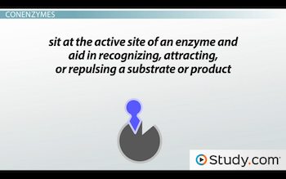 | Coenzymes bind loosely to the active site of enzymes.

Prosthetic Groups
Prosthetic groups are cofactors that bind tightly to proteins or enzymes. As if holding on, they are not easily removed. They can be organic or metal ions and are often attached to proteins by a covalent bond. The same cofactors can bind multiple different types of enzymes and may bind some enzymes loosely, as a coenzyme, and others tightly, as a prosthetic group. Some cofactors may always tightly bind their enzymes. It's important to note, though, that these prosthetic groups can also bind to proteins other than enzymes.
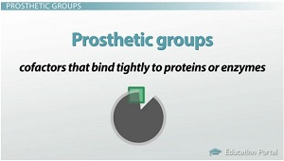
Prosthetic groups can be either organic or metal ions.
Isozymes: Multiple forms of enzymes that differ in amino acid sequence but catalyze the same chemical reaction. Although they have the same catalytic activity, they are physically distinct and differ in chemically, immunologically, electrophoretic mobility and liability to inhibitors.
Example of isoenzymes
Many enzymes are present in isoenzyme form:
1. Lactate dehydrogenase
2. Creatine kinase
3. Acid phosphatase
4. Alkaline phosphatase
5. Lactate dehydrogenase

Multi-enzyme Many enzymes in living cells catalyses chains of reaction in a sequential order either in a biosynthetic or a catabolic pathway. The series of enzymes catalyzing such chains of reactions are said to form a multi-enzyme system.
The enzymes act as independent entities each interacting with its own substrate, forms product. The product formed from each reaction is acted upon by another enzyme of the sequence. Some of the multi-enzyme systems may operate in a different way, when the enzymes are closely associated with each other to form a multi-enzyme complex.
The fatty acid synthetase of yeast provides an example of a multi-enzyme complex. It consists of seven different enzymes which form a tightly bound cluster. Each enzyme of the complex catalyzes a different reaction, ultimately producing a long- chain fatty acid.
A B C D E F end product is F

Enzymes involved in chain reactions are

A-------B (enzyme 1)

B-------C (enzyme 2)

C-------D (enzyme 3) Multi-enzymes

D-------E (enzyme 4)

E-------F (enzyme 5)

Enzymes Classification
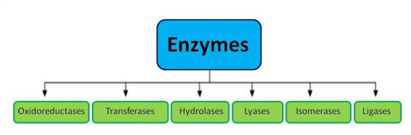
According to the International Union of Biochemists (I U B), enzymes are divided into six functional classes and are classified based on the type of reaction in which they are used to catalyze. The six types of enzymes are oxidoreductases, hydrolases, transferases, lyases, isomerases, ligases.
Following are the enzymes classifications in detail:
Types | Biochemical Property
Oxidoreductases | The enzyme Oxidoreductase catalyzes the oxidation reaction where the electrons tend to travel from one form of a molecule to the other.
Transferases | The Transferases enzymes help in the transportation of the functional group among acceptors and donors molecules.
Hydrolases | Hydrolases are hydrolytic enzymes, which catalyze the hydrolysis reaction by adding water to cleave the bond and hydrolyze it.
Lyases | Adds water, carbon dioxide or ammonia across double bonds or eliminate these to create double bonds.
Isomerases | The Isomerases enzymes catalyze the structural shifts present in a molecule, thus causing the change in the shape of the molecule.
Ligases | The Ligases enzymes are known to charge the catalysis of a ligation process.

Oxidoreductases
These catalyze oxidation and reduction reactions,e.g. pyruvate dehydrogenase, which catalyzes the oxidation of pyruvate to acetyl coenzyme A.

Transferases
These catalyze the transfer of a chemical group from one compound to another. An example is a transaminase, which transfers an amino group from one molecule to another.

Hydrolases
They catalyze the hydrolysis of a bond. For example, the enzyme pepsin hydrolyzes peptide bonds in proteins.

Lyases
These catalyze the breakage of bonds without catalysis, e.g. aldolase (an enzyme in glycolysis) catalyzes the splitting of fructose-1, 6-bisphosphate to glyceraldehyde-3-phosphate and dihydroxyacetone phosphate.

Isomerases
They catalyze the formation of an isomer of a compound. Example: phosphoglucomutase catalyzes the conversion of glucose-1-phosphate to glucose-6-phosphate (transfer of a phosphate group from one position to another in the same compound) in glycogenolysis (conversion of glycogen to glucose for quick release of energy.

Ligases
Ligases catalyze the joining of two molecules. For example, DNA ligase catalyzes the joining of two fragments of DNA by forming a phosphodiester bond.

Mechanism of enzyme Action
An enzyme attach the substrates to its active site, catalyzes the chemical reaction by which products are formed, and then allows the products to dissociate (separate from the enzyme surface). The combination formed by an enzyme and its substrates is called the enzyme–substrate complex. When two substrates and one enzyme are involved, the complex is called a ternary complex; one substrate and one enzyme are called a binary complex. The substrates are attracted to the active site by electrostatic and hydrophobic forces, which are called non-covalent bonds because they are physical attractions and not chemical bonds. In any chemical reaction, a substrate (S) is converted into a product (P):

S P

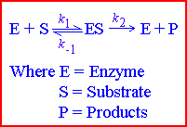
(There may be more than one substrate and more than one product, but that doesn't matter here.) In an enzyme-catalysed reaction, the substrate first binds to the active site of the enzyme to form an enzyme-substrate (ES) complex, then the substrate is converted into product whilst attached to the enzyme, and finally the product is released, thus allowing the enzyme to start all over again (see right)

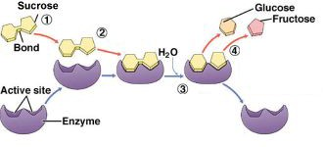

An example is the action of the enzyme sucrase (enzyme) hydrolysing sucrose into glucose and fructose

Enzyme substrate interaction
A model for enzyme-substrate interaction suggesting that the enzyme and the substrate possess specific complementary geometric shapes that fit exactly into one another.
Enzymes are highly specific. They must bind to a specific substrate before they can catalyze a chemical reaction. At present, there are two models, which attempt to explain enzyme specificity: (1) lock-and-key model and (2) induced fit model.

- lock-and-key model
In lock-and-key model, the enzyme-substrate interaction suggests that the enzyme and the substrate possess specific complementary geometric shapes that fit exactly into one another. This theory proposed that the substrate molecule is complementary in shape to that of the active site of enzyme. It was thought that the substrate exactly fitted into the active site of the enzyme molecule like a key fitting into a lock (the now discredited ‘lock and key’ theory). This explained why an enzyme would only work on one substrate (specificity), but failed to explain why the reaction happened. The lock and key model theory first postulated by Emil Fischer in 1894 shows the high specificity of enzymes. However, it does not explain the stabilization of the transition
state that the enzymes achieve.

Main point of the lock and key model
- the enzyme’s active site complements the substrate precisely
- The substrate fits a particular active site like a key fits into a particular lock
- This theory of enzyme-substrate interaction explains how enzymes exhibit specificity for a particular substrate

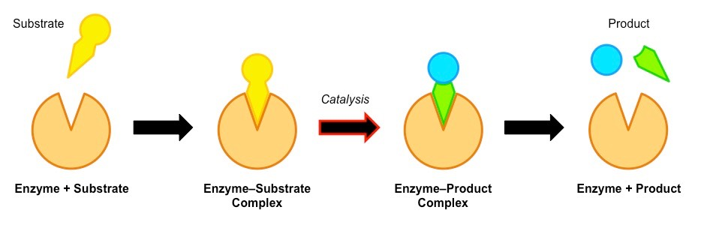

- Induced fit model
As for the induced fit model suggested by Daniel Koshland in 1958, it suggests that the active site continues to change until the substrate is completely bound to the active site of the enzyme, at which point the final shape and charge is determined. Unlike the lock-and-key model, the induced fit model shows that enzymes are rather flexible structures.

Main point of induced fit model
- the active site will undergo a conformational change when exposed to a substrate to improve binding
- it has two advantages compared to the lock and key model as may exhibit broad specificity (e.g. lipase can bind to a variety of lipids), the conformational change stresses bonds in the substrate, increasing reactivity

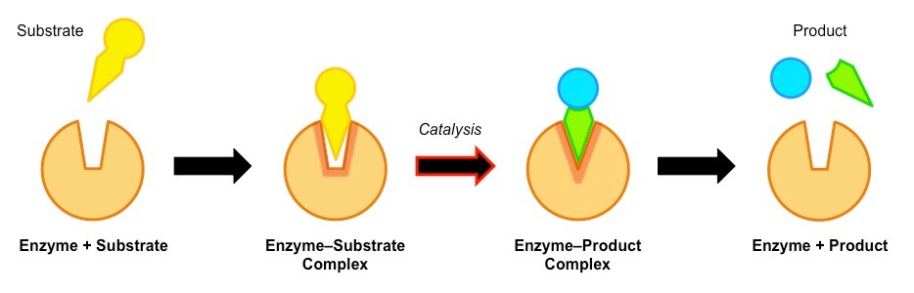

Induced Fit model

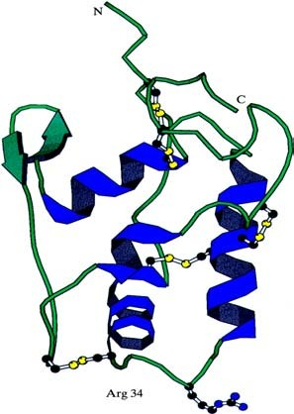
But It is now known that the substrate and the active site both change shape when the enzyme-substrate complex is formed, bending (and thus weakening) the target bonds. For example, if a substrate is to be split, a bond might be stretched by the enzyme, making it more likely to break. Alternatively the enzyme can make the local conditions inside the active site quite different from those outside (such as pH, water concentration, charge), so that the reaction is more likely to happen.

Although enzymes can change the speed of a chemical reaction, they cannot change its direction, otherwise they could make "impossible" reactions happen and break the laws of thermodynamics. So an enzyme can just as easily turn a product into a substrate as turn a substrate into a product, depending on the local concentrations. The transition state is the name given to the distorted shape of the active site and substrate.
This diagram shows another enzyme with its 5
disuphide bridges in yellow and regions of α –helix in blue. The active site is near the region of the arrows.
Activation Energy
Enzymes neither initiate the reaction nor affect the equilibrium ratio of reactants and products. Rather, enzymes accelerate the rate of reaction 10⁸ to 10¹² times in both directions to attain the equilibrium position.
In a reaction where the product has a lower energy than the substrate, the substrate naturally turns into product (i.e. the equilibrium lies in the direction of the product). Before it can change into product, the substrate must overcome an "energy barrier" called the activation energy. The larger the activation energy is, the slower the reaction will be. This is because only a few substrate molecules will have sufficient energy to overcome the activation energy barrier. Imagine pushing boulders over a hump before they can roll down hill, and you have the idea. Most biological reactions have large activation energies, so they without enzymes they happen far too slowly to be useful. Enzymes reduce the activation energy of a reaction so that the kinetic energy of most molecules exceeds the activation energy required and so they can react.

For example, for the catalase reaction (2H₂O₂ → 2H₂O + O₂) the activation energy is 86 kJ mol⁻¹ with no catalyst, 62 kJ mol⁻¹ with an inorganic catalyst, and just 1 kJ mol⁻¹ with the enzyme catalase.

Factors that Affect the Rate of Enzyme Reactions

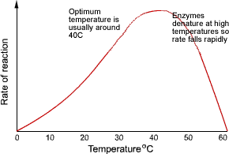
Temperature

Enzymes have an optimum temperature at which they work fastest. For mammalian enzymes this is about 40°C, but there are enzymes that work best at very different temperatures, e.g. enzymes from the arctic snow flea work at -10°C, and enzymes from thermophilic bacteria work at 90°C.

Up to the optimum temperature the rate increases geometrically with temperature (i.e. it's a curve, not a straight
line). The rate increases because the enzyme and substrate molecules both have more kinetic energy and so collide more often, and also because more molecules have sufficient energy to overcome the activation energy.
Above the optimum temperature the rate decreases as more of the enzyme molecules denature. The thermal energy breaks the hydrogen bonds holding the secondary and tertiary structure of the enzyme together, so the enzyme loses its shape and becomes a random coil - and the substrate can no longer fit into the active site. This is irreversible. Remember that only the hydrogen bonds are broken at normal temperatures; to break the primary structure ( the peptide bonds) you need to boil in strong acid for several hours – or use a protease enzyme!
The increase in rate with temperature can be quantified as the Q₁₀, which is the relative increase for a 10°C rise in temperature. Q₁₀ is usually around 2 for enzyme-catalysed reactions (i.e. the rate doubles every 10°C) and usually less than 2 for non-enzyme reactions.

The rate is not zero at 0°C, so enzymes still work in the fridge (and food still goes off), but they work slowly. Enzymes can even work in ice, though the rate is extremely slow due to the very slow diffusion of enzyme and substrate molecules through the ice lattice.

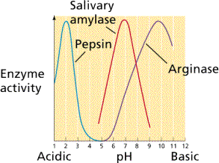
pH

Enzymes have an optimum pH at which they work fastest. For most enzymes this is about pH 7-8 (normal body pH), but a few enzymes can work at extreme pH, such as gastric protease (pepsin) in our stomach, which has an optimum of pH 1.
The pH affects the charge of the amino acids at the active site, so the properties of the active site change and the substrate can no longer bind. For example a carboxyl acid R groups will be uncharged a low pH (COOH), but charged at high pH (COO⁻).

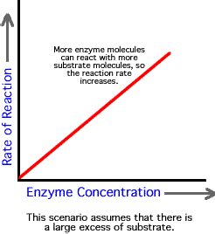
Enzyme concentration

As the enzyme concentration increases the rate of the reaction also increases, because there are more enzyme molecules (and so more active sites), available to catalyse the reaction therefore more enzyme-substrate complexes form. In cells, the substrate is always in excess, so the graph does not level out. In the lab, these conditions need not apply and a plateau can be reached.

4. Substrate concentration
The rate of an enzyme-catalysed reaction is also affected by substrate concentration. As the substrate concentration increases, the rate increases because more substrate molecules can collide with active sites, so more enzyme-substrate complexes form.
At higher concentrations the enzyme molecules become saturated with substrate, and there are few free active sites, so adding more substrate doesn't make much difference (though it will increase the rate of E-S collisions).
The maximum rate at infinite substrate concentration is called v_{max}, and the substrate concentration that gives a rate of half v_{max} is called K_{M}. These quantities are useful for characterising an enzyme. A good enzyme has a high v_{max} and a low K_{M}.

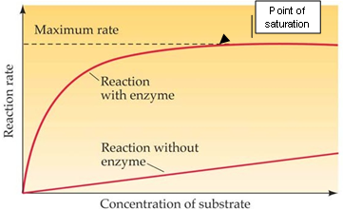

Covalent modification

The activity of some enzymes is controlled by other enzymes, which modify the protein chain by cutting it, or adding a phosphate or methyl group. This modification can turn an inactive enzyme into an active enzyme (or vice versa), and this is used to control many metabolic enzymes and to switch on enzymes in the gut e.g. HCl in stomach → activates pepsin → activates rennin.

Inhibitors

Inhibitors inhibit the activity of enzymes, reducing the rate of their reactions. They are found naturally, but are also used artificially as drugs, pesticides and research tools. There are two kinds of inhibitors.

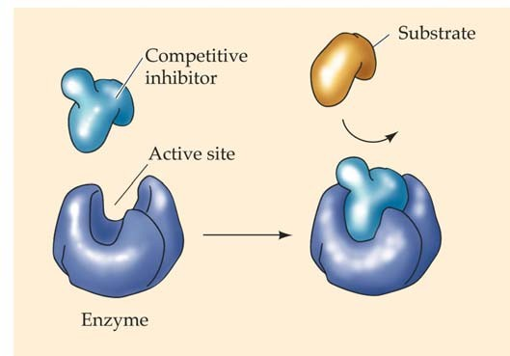
- A competitive inhibitor molecule has a similar structure to the substrate molecule, and so it can fit into the active site of the enzyme. It therefore competes with the substrate for the active site, so the reaction is slower. Increasing the concentration of substrate restores the reaction rate and the inhibition is usually temporary and reversible. Competitive inhibitors increase K_{M} for the enzyme, but have no effect on v_{max}, so the rate can approach a normal rate if the substrate concentration is increased high enough.

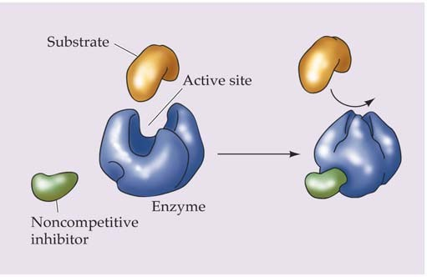
- A non-competitive inhibitor molecule is quite different in structure from the substrate and does not fit into the active site. It binds to another part of the enzyme molecule, changing the shape of the whole enzyme, including the active site, so that it can no longer bind substrate molecules. Non-competitive inhibitors therefore simply reduce the amount of active enzyme. This is the same as decreasing the enzyme concentration, so they decrease v_{max}, but have no effect on K_{M}. This kind of inhibitor tends to bind
tightly and irreversibly – such as the poisons cyanide and heavy metal ions. Many nerve poisons (insecticides) work in this way too.

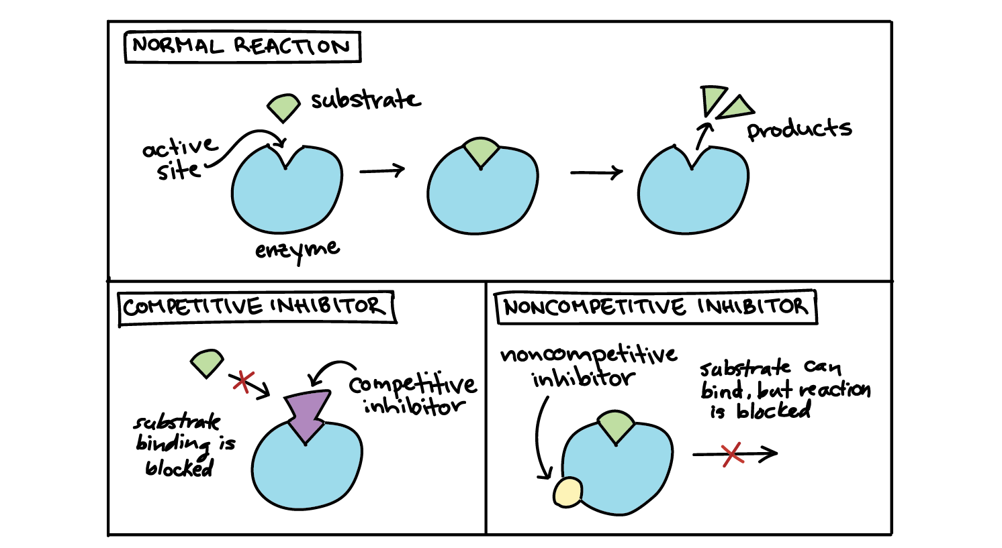

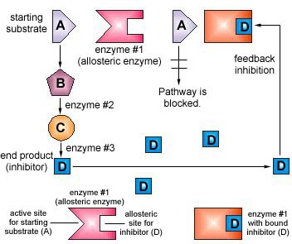
- Feedback Inhibition (Allosteric Effectors)

The activity of some enzymes is controlled by certain molecules binding to a specific regulatory (or allosteric) site on the enzyme, distinct from the active site. Different molecules can either inhibit or activate the enzyme, allowing sophisticated control of the rate. Only a few enzymes can do this, and they are often at the start of a long biochemical pathway. They are generally activated by the substrate of the pathway and inhibited by the product of the pathway, thus only turning the pathway on when it is needed. This process is known as feedback inhibition.

Allosteric enzymes:
Allosteric enzymes are enzymes that have an additional binding site for effector molecules other than the active site. The binding brings about conformational changes, thereby changing its catalytic properties. The effector molecule can be an inhibitor or activator.
All the biological systems are well regulated. There are various regulatory measures in our body, that control all the processes and respond to the various inside and outside environmental changes. Whether it is gene expression, cell division, hormone secretion, metabolism or enzyme activity, everything is regulated to ensure proper development and survival.
Allostery is the process of enzyme regulation, where binding at one site influences the binding at subsequent sites.
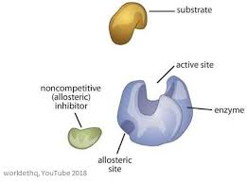

Allosteric Enzyme Properties
- Enzymes are the biological catalyst, which increases the rate of the reaction
- Allosteric enzymes have an additional site, other than the active site or substrate binding site. The substrate-binding site is known as C-subunit and effector binding site is known as R-subunit or regulatory subunit
- There can be more than one allosteric sites present in an enzyme molecule
- They have an ability to respond to multiple conditions, that influence the biological reactions
- The binding molecule is called an effector, it can be inhibitor as well as activator
- The binding of the effector molecule changes the conformation of the enzyme
- Activator increases the activity of an enzyme, whereas inhibitor decreases the activity after binding
- The velocity vs substrate concentration graph of allosteric enzymes is S-curve as compared to the usual hyperbolic curve

Properties of Enzymes

1. Proteinous nature:

Nearly all enzymes are proteins although some catalytically active RNA molecules have been identified.

2. Colloidal nature:

In the protoplasm, enzymes exist as hydrophilic colloids. Due to colloidal nature, they are isolated by dialysis.

3. Substrate specificity:

A given enzyme only catalyzes one reaction or a similar type of reaction. For example, maltase acts only on maltose while pancreatic lipase acts in a variety of fats. Sometimes, different enzymes may act on the same substrate to produce different end products. The substrate specificity of enzyme is based on amino acids sequence in the catalytic site as well as the optical isomeric form of the substrate.

4. Catalytic properties:

(i) Enzyme require in small concentration for any chemical change,

(ii) They don’t initiate the catalysis but accelerate the rate of catalysis by lowering the activation energy,

(iii) They remain unchanged at the end of reaction,

(iv) Their presence don’t alter the properties of end products,

(v) Enzymes accelerate the forward or reverse reactions to attain the equilibrium but don’t shift the equilibrium,

(vi) Usually enzyme catalyzed reactions are reversible, but not always,

(vii) They require hydration for activity.

5. Enzyme efficiency:

It is the number of substrate molecules changed per unit of time per enzyme. Typical turn over number varies form 102 to 103 sec-1. For example the turn over number for sucrase is 104, that means, one sucrase molecule convert 10,000 sucrose into products. Similarly, it is 36 million for carbonic anhydrase (fastest enzyme) and 5 million for catalase (2nd fastest enzymes). Enzyme efficiency is very low in Lysozyme.

6. Sensitivity:

Enzymes are highly sensitive to change in pH, temperature and inhibitors. Enzymes work best at a narrow range of condition called optimum.

(i) Temp:

The optimum temp of enzymes is 20-35°C. They become inactivated at very low temperature and denatured (destroyed) at very high temp i.e. greater than 45°C. Low molecular weight enzymes are comparatively more heat stable. In archebacterium Pyrococcus furious, the optimum temperature of hydrogenise is greater than 95°C. This heat-stable enzyme enables Pyrococcus to grow at 100°C.

(ii) pH:

The optimum pH of most endoenzyme is pH 7.0 (neutral pH). However, digestive enzymes can function at different pH. For example, salivary amylase act best at pH 6.8, pepsin act best at pH2 etc. Any fluctuation in pH from the optimum causes ionization of R-groups of amino acids which decrease the enzyme activity. Sometime a change in pH causes the reverse reaction, e.g. at pH 7.0 phosphorylase break down starch into glucose 1- phosphate while at pH5 the reverse reaction occurs.

(iii) Inhibitors:
Enzymes are also sensitive to inhibitors. Inhibitors are any molecules like cellular metabolites, drugs or toxins which reduce or stop enzyme activity. Enzyme inhibitors are of 2 types i.e. reversible and irreversible.

