Dr. Rima Kumari: Date: 09/09/2020
Online class and e- content for BSc IInd year students
Date and Time | Online class medium | E. content topic
09/09/2020  01:30 p.m to 2.20 p.m | Via Google meet  Link: Meeting URL: https://meet.google.com/ece-ftjm-cpp | Role of Microbes in Nitrogen fixation

Chapter: Role of Microbes in Nitrogen fixation

Nitrogen fixation:
Apart from carbon, hydrogen and oxygen, nitrogen is the most important essential macro-element in living organisms. Plants need nitrogen to build amino acids, proteins, nucleic acids, cytochromes, chlorophylls, alkaloids, phytohormones and many of the vitamins. Plants compete with microbes for limited nitrogen content available in the soil.
Nitrogen occurs in atmosphere as free diatomic (N₂) molecules form. Nearly 80% of Earth atmosphere contains nitrogen in the form of a highly inert di-nitrogen (N = N) which most plants cannot utilize as such, and therefore has to be fixed. Nitrogen-fixing microorganism capable to fixes atmospheric nitrogen into biologically available form (in inorganic compounds usable by plants). This termed as nitrogen fixation.
Means of Nitrogen fixation:
- physicochemical (non-biological) About 10% of natural nitrogen fixation takes place by physicochemical methods
- Biological means. 90% by biological methods.

Physical nitrogen fixation
i) by environmental physical factors lightning (electric discharge in the clouds) and thunder, in these cases N₂ and O2 of the air react to form nitric oxide (NO). The nitric oxides are again oxidized with oxygen to form nitrogen peroxide (NO₂).

(ii) Industrial Nitrogen Fixation:
Ammonia is produced industrially by direct combination of nitrogen with hydrogen (obtained from water) at high temperature and pressure. Later, it is converted into various kinds of fertilizers, such as urea etc.

Biological nitrogen fixation:
More than 90 percent of all nitrogen fixation is affected by micro-organisms, which thus play an important role in the nitrogen cycle. The conversion of atmospheric nitrogen into the nitrogenous compounds through the agency of micro-organisms is called biological nitrogen fixation (BNF). So Biological nitrogen fixation is the phenomenon of reduction of inert gaseous di-nitrogen (N₂) into ammonia (NH₃) through the agency of some microorganisms so that it can be made available to the plants. Biological nitrogen fixation is also called as diazotrophy and micro-organism involved in process of biological nitrogen fixation is called diazotrophs. It occur due to presence of enzyme nitrogenize produced by certain microbes. Nitrogenize is a biological catalyst found naturally only in certain microorganisms such as the symbiotic Rhizobium and Frankia, or the free-living Azospirillum and Azotobacter and blue green algae (BGA) and this enzyme help in process of biological nitrogen fixation

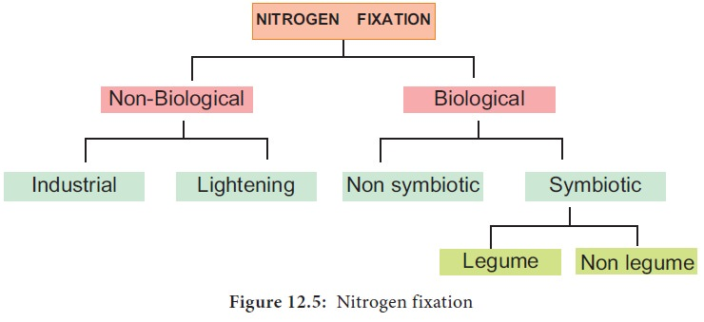

Role of Microbes in Biological nitrogen fixation

Mainly two main types of microorganism involved in biological nitrogen fixation:
- Free-living (non-symbiotic) Nitrogen Fixing bacteria
- Symbiotic Nitrogen Fixing bacteria

Non-symbiotic bacteria:
- Free-living (non-symbiotic) Nitrogen Fixing bacteria Azotobacter, Beijerinckia (bothaerobic) and Clostridium (anaerobic) are saprophytic bacteria that perform nitrogen fixation. Desulphovibrio is chemotrophic nitrogen fixing bacterium. Rhodopseudomonas, Rhodospirillum and Chromatium are nitrogen fixing photoautotrophic bacteria. These bacteria add up to 10-25 kg, of nitrogen/ha/annum. Free-living (non-symbiotic) Nitrogen Fixing cyanobacteria Many free living blue-green algae (now called cyanobacteria) perform nitrogen fixation, e.g., Anabaena, Nustoc, Aulosira, Cylmdrospermum, Trichodesmium. These are also important ecologically as they live in water-logged sods where denitrifing bacteria can be active. Aulosira fertilissima is the most active nitrogen fixer in Rice fields, while Cylindrospermum is active in sugarcane and maize fields. They add 20-30 kg Nitrogen/ha/annum.

Symbiotic bacteria:
Symbiotic Nitrogen Fixing bacteria
Rhizobium is aerobic, gram negative nitrogen fixing bacterial symbionts of Leguminaceae roots. Several species of Rhizobium live in the soil but are unable to fix nitrogen by themselves. They do so only as symbionts in the association of roots of legumes. Sesbania rostrata has Rhizobium in root nodules and Aerorhizobium in stem nodules. Frankia is symbiont in root nodules of many non-leguminous plants like Casuarina and Alnus. Xanthomonas and Mycobacterium occur as symbiont in the leaves of some members of the families Rubiaceae and Myrsinaceae (e.g., Ardisia). Frankia, associated with certain dicotyledonous species (actinorhizal plants); and certain Azospirillum species, associated with cereal grasses.
Symbiotic Nitrogen Fixing cyanobacteria
Anabaena and Nostoc species are common symbionts in lichens, Anthoceros, Azolla and cycad roots. Azolla pinnata (a water fern) has Anabaena azollae in its fronds. It is often inoculated to Rice fields for nitrogen fixation.
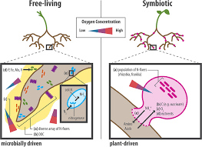

Symbiotic Nitrogen Fixation:
Both Rhizobium sp. and Frankia are free living in soil, but only as symbionts, can fix atmospheric di-nitrogen. The symbiotic nitrogen-fixing bacteria invade the root hairs of host plants, where they multiply and stimulate the formation of root nodules, enlargements of plant cells and bacteria in intimate association. Within the nodules, the bacteria convert free nitrogen to ammonia, which the host plant utilizes for its development. To ensure sufficient nodule formation and optimum growth of legumes (e.g., alfalfa, beans, clovers, peas, and soybeans), seeds are usually inoculated with commercial cultures of appropriate Rhizobium species, especially in soils poor or lacking in the required bacterium.
