Volvox

Systematic Position of Volvox:
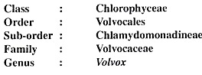

Occurrence of Volvox:
Volvox is free floating fresh water green algae. Volvox grows as planktons on surface of water bodies like temporary and permanent ponds, lakes and water tanks. During rainy season due to its fast growth the surface of water bodies become green. The Volvox colonies appear as green rolling balls on surface of water.
Volvox is represented by about 20 species:
Some common Indian species are—Volvox globator, V aureus, V. prolificus, V. africanus and V. rousseletii.

Structure of Volvox:
Volvox thallus is a motile colony with definite shape and number of cells. This habit of thallus is called coenobium.
The colony is hollow, spherical or oval in shape and the size of colony is about the size of a pin head. The number of cells in a colony is fixed. Depending upon the species of Volvox the cells can be 500-60,000. The central part of colony is mucilaginous and the cells are arranged in a single layer on periphery of the colony (Fig. 1A).
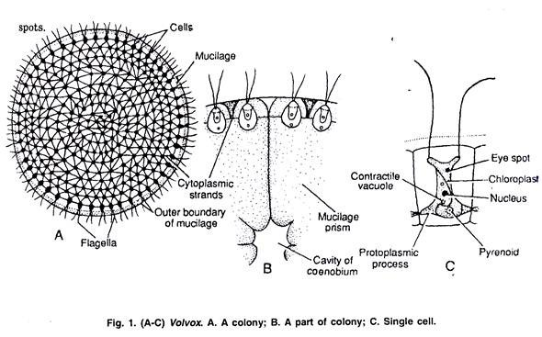
The cells of anterior end possess bigger eye spots than those of posterior end cells. The cells of posterior side become reproductive on maturity. Thus, spherical or round colony of Volvox shows clear polarity. The cells of Volvox colony are Chlamydomonas type. Every cell has its own mucilage sheath (Fig. 1 B).
The mucilage envelope of colony appears angular due to compression between cells. The cells are connected to each other through cytoplasmic strands. In some species of Volvox the cytoplasmic connections or strands are not present.
The cells of colony are usually pyriform with narrow anterior end and broad posterior end. The cells are biflagellate, the two flagella are equal, whiplash type and project outwards (Fig. 1 C). The protoplasm of cell is enclosed within plasma membrane.
Each cell contains one nucleus, a cup shaped chloroplast with one or more pyrenoids, an eye spot and 2-6 contractile vacuoles. In some species of Volvox e.g., in V. globator and V. rousseletii the cells are of Sphaerella type.
The cells of colony are independent for functions like photosynthesis, respiration and excretion. The movement of colony takes place by co-ordinated flagellar movement. The reproduction is common to the coenobium.

