TDC Part II
Paper I, Group B
Inorganic Chemistry

Department of Chemistry

L.S COLLEGE MUZAFFARPUR
B. R. A. BIHAR UNIVERSITY
Dr. Priyanka

TOPIC:-UNIT -3, SPECTRAL PROPERTIES AND STEREOCHEMISTRY OF THE ELEMENTS OF THE SECOND TRANSITION SERIES

SPECTRAL PROPERTIES AND STEREOCHEMISTRY OF THE ELEMENTS OF THE SECOND TRANSITION SERIES

We know that the electromagnetic radiations of white light such as sunlight consist of a continuous spectrum of wavelengths corresponding to different colours. If such a light falls on a compound, the light-matter interaction results in the absorption of either all the radiations giving black colour to the compound, or that of one radiation of a particular colour. In the latter case, the light of different colour is transmitted or reflected which is the complementary colour of the absorbed colour
and is the colour of the compound. If the compound does not absorb in the visible region, it appears white.

The transition metal ions / compounds / complexes show a variety of colours depending on the nature of metals and ligands. The colour of a compound arises due to the transition of electron(s) from ground state (lowest energy) to the excited state (higher energy). When a photon having energy equal to the difference between the two states, i.e., ground and excited state, strikes the compound or the ion, electronic transition (here promotion) takes place. In the complexes of the transition metals, this transition occurs from t₂g to e_{g} level in octahedral field and from e to t₂ level in tetrahedral ligand environment. The energy difference between the two states involved in electronic transition is given by (as given in the figure 2.1) the following:

hc 1
∆E = E₂ - E₁ = ℎv = fi = hv (∴ v =fi)

Where ∆E = energy, h = Planck’s constant, c = velocity of light, λ = wavelength of light absorbed, v = frequency of light absorbed and v = wave number.
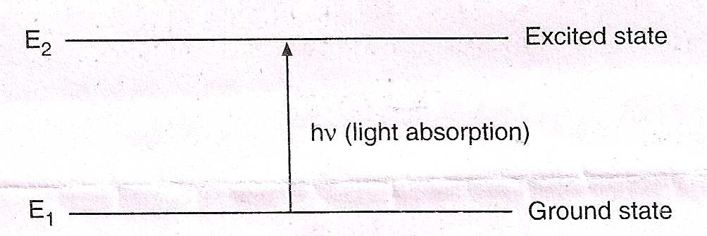

Fig. 2.1

The colour of the compound / complex exhibited due to the above transition is called the colour due to d-d transition. The examples of compounds / complexes which are coloured due to d-d transitions are provided by first transition (3d) series elements and a few heavier elements. Greater is ∆, more energy is required to cause the d-d transition. For 4d-series elements, increasing ∆ value in octahedral field is: Mo³⁺ < Rh³⁺ < Ru³⁺ < Pd⁴⁺ etc.

The other types of electronic transitions which are responsible for the colours of the ions / compounds / complexes, particularly, of second transition (4d) series elements are the charge transfer processes (C.T.) from metal to ligand or ligand to metal. The electronic spectra of the complexes / compounds of second and third transition series elements are less important than those of the complexes of first transition series elments because in the former case the d-d and C.T. bands can not be separated but this is possible in the latter case. In the compounds / complexes of heavier elements of 4d series because of the larger magnitude of ∆ (Crystal field splitting energy), the d-d bands are found at lower wave lengths and hence overlap with the C.T. bands. The charge transfer process is similar to the internal redox process because electron transfer takes place during this process from metal to ligand or ligand to metal within a complex/compound. In heavier transition metal complexes the latter is generally observed. Thus, it is possible to classify and rank the metal ions according to their oxidising power Rh⁴⁺ > Ru⁴⁺ > Ru³⁺ > Pd²⁺ > Rh³⁺, etc. Greater the oxidising power of the metal ion and also greater the reducing power of the ligands, lower the energy at which the C.T. bands appear.

Charge transfer transitions are Laporte and spin allowed, unlike d-d transitions, i.e., ∆l = ±1 and ∆ s = 0 because in these transitions, there occurs a transition of electron(s) between the orbitals of different atoms, viz., metal and ligand. These give rise to more intense or strong absorptions. When these transitions occur in visible region, the compound / complex shows intense colour.

These transitions are of four types:

- Ligand to metal transitions
- Metal to ligand transitions
- Intervalence or metal to metal transitions
- Intra ligand charge transfer

Among the oxo ions of 4d series elements, the decreasing order of energy of ligand to metal charge transfer is as follows:

NbO₄³⁻ > MoO₄²⁻ > TcO ⁻
4

But, the energy of charge transfer increases for the similar ions of 5d-series elements. For the above ions. The energy difference between 2p-orbitals of oxide ion and 4d-orbitals of the metal ions is very large lying in UV region and hence these ions are colourless.

An example of metal-metal (or inter valence) charge transfer is the Ru-complex given below: (Fig. 2.2)
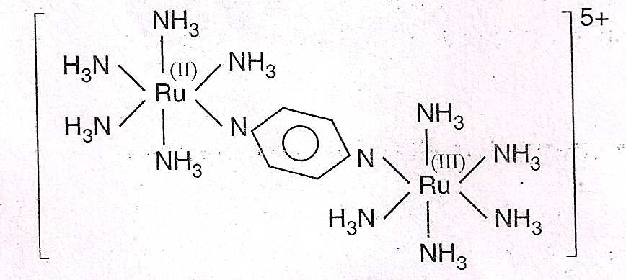

or [(NH₃)₅Ru^{II} – Pyz – Ru^{III}(NH₃)₅]⁵⁺ where bridging ligand is pyrazine group. In this complex electronic transition occurs from Ru(II) to Ru(III) through Pyz-bridging ligand and gives intense colour. The compounds with M-M bonds also give intense colour, e.g., [Mo₂Cl₈]⁴⁻ is red in colour. Also, the metal carbonyls with M-M bonds are often intensely coloured (e.g., polynuclear carbonyls).

