Dr. Rima Kumari: Date: 08/07/2020
Online class and e- content for B.Sc. IInd year students

Date and Time | Online class medium | E. content topic
08/07/2020  11:40 p.m to 12.30 p.m | Via Google meet  Link: Meeting URL: https://meet.google.com/vms-rneg-hyk | Plant Tissue culture

Chapter: Plant Tissue culture
Plant tissue culture may be defined as in vitro (in glass vessels, in laboratory) culture of an explant (cell tissue, organ or any plant part used to initiate in vitro culture e.g. shoot tip, leaf, petiole etc.) to generate entire plant. The resultant plants are clone type of the selected genotype. In commercial purpose, tissue culture is primarily used for plant propagation and is often referred to as micropropagation.
Aseptic conditions (sterile; free from microorganisms), controlled environment (uniform temperature, humidity, light duration etc.), a specific culture medium (which provides nutrient for plant growth and usually contains one or more plant growth regulators) maintained in tissue culture. The appropriate composition of organic and inorganic nutrients in culture medium largely determines the success of the culture. The culture media used for the in vitro cultivation of the plant cells are composed of three basic components i) Essential elements supplied as a complex mixture of salts. ii) An organic supplements providing vitamins and amino acids. Usually sucrose supplied as fixed carbon source.
Tissue culture techniques are used for production of disease-free plants, genetic manipulation, plant improvement, producing high yield crop, mass multiplication of desired plant and basic research purpose.
Basics of Plant Tissue Culture:
- G. Haberlandt, a German botanist, in 1902 cultured fully differentiated plant cells isolated from different plants. This was the very first step for the beginning of plant cell and tissue culture. Further contributions were made by the Cell Doctrine which admitted that a cell is capable of showing totipotency.
- The first plant from a mature plant cell was regenerated by Braun in 1959. Foundation of commercial plant tissue culture was laid in 1960 with the discovery for a million fold multiplication of Cymbidium (an orchid) which was accomplished by G.M.Morel. Then after the development of a reliable artificial medium by Murashige & Skoog, 1962, that plant tissue culture really ‘took off’ at commercial level.
- In India, the work on tissue culture was initiated by P.Maheshwari (Delhi University) after discovery of haploid production of plants by in-vitro culturing.
- Shri S.C. Maheshwari and Sipra Guha made a remarkable contribution in the development of plant tissue culture in India.
- G. Haberlandt was the first person who developed the concept of in-vitro culture of plant cells and is aptly regarded as the father of tissue culture.

Principles of Plant Tissue Culture
The basic concept of the plant tissue culture is to produce a higher number of plants that are genetically similar to a parent plant. For this purpose “explant” (small dissected part of plant) is used for tissue culture to develop it into a whole plant. This technique is effective because almost most of the plants cell are totipotent (having ability to generate into whole plant) as each cell possesses the genetic information and cellular machinery necessary to generate the whole organism.
So on, basic principles of Plant tissue culture relies on these facts that:
- Cell plasticity: Plants, due to its longer life span and sessile nature, have developed a greater ability to adapt and overcome the extreme conditions (environmental and biotic). This empowers the plant development and their growth. When the plant cells and tissues are cultured in vitro, most of them are generally exhibit a very high degree of plasticity, which allows one type of organ or tissue to be initiated from another type. Like this way, the whole plant can be subsequently regenerated.
- Totipotency: Totipotency forms the basis of successful plant tissue culture. The theory of Totipotency states that each cell has the ability to regenerate into a complete plant. Each somatic cell has the same genetic constitution (DNA sequence) as that of a zygote, and hence, also has the potential of expressing all the properties of an organism. Single cells, plant cells without cell walls (protoplasts), pieces of leaves, stems or roots can often be used to generate a new plant on culture media given the required nutrients and plant hormones. Since, handling a single cell is practically difficult, therefore, usually a tissue or an organ form the plant is used to initiate the tissue culture work and hence Plant Tissue Culture is often also called as Plant Cell, Tissue and Organ Culture.
The controlled conditions provide the culture an optimum environment condition for their growth and multiplication. These conditions include the proper supply of nutrients, pH medium, adequate temperature, and proper gaseous and liquid environment.
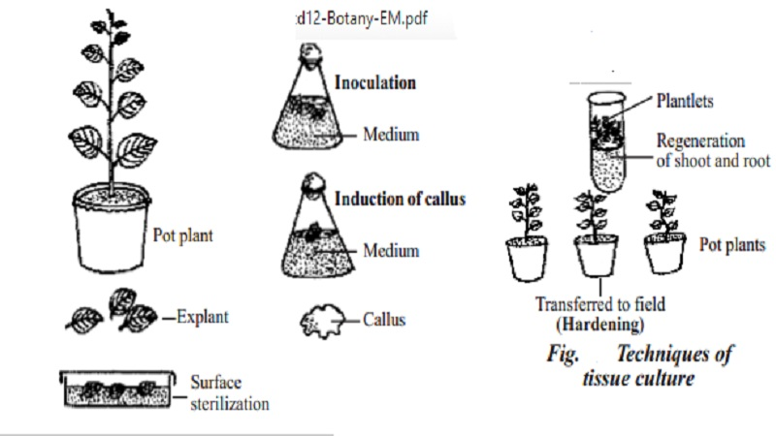
Plant tissue culture
Significance of Plant tissue culture
- Plant tissue culture technology is being widely used for large scale production of specific plant type .
- Apart from their use as a tool of research, plant tissue culture techniques have in recent years, become of major industrial importance in the area of plant propagation, disease elimination, plant improvement and production of secondary metabolites.
- Small pieces of tissue (named explants) can be used to produce hundreds and thousands of plants in a continuous process. A single explant can be multiplied into several thousand plants in the relatively short time period and space under controlled conditions, irrespective of the season and weather on a year-round basis.
- Endangered, threatened and rare species have successfully been grown and conserved by micropropagation because of high coefficient of multiplication and small demands on the number of initial plants and space.
- In addition, plant tissue culture is considered to be the most efficient technology for crop improvement by the production of somaclonal and gametoclonal variants.
- The micropropagation technology has a vast potential to produce plants of superior quality, isolation of useful variants in well-adapted high yielding genotypes with better disease resistance and stress tolerance capacities
Alongwith, plant tissue culture has become of great interest to the molecular biologists, plant breeders and even to the industrialists, as it helps in improving the plants of economic importance. In addition to all this, the tissue culture contributes immensely for understanding the patterns and responsible factors of growth, metabolism, morphogenesis and differentiation of plants.
Important terminologies
Aseptic – The state of being free of contaminating organisms (bacteria, fungi, algae and all micro-organisms except viruses)
Callus – A mass of thin-walled, undifferentiated plant cells, meristematic (high regeneration capacity) in nature. It developed as the result of culture on nutrient media.
Clone –genetically identical plants developed by process of in-vitro tissue culture, vegetative propagation or, without involving sexual process.
Differentiation – A process in which unspecialized cells develop structures and functions characteristic of a particular type of cell. Development from one cell to many cells, accompanied by a modification of the new cells for the performance of particular functions. In tissue culture, the term is used to describe the formation of different cell types.
Excision – Cutting out and preparing a tissue, organ, etc., for culture.
Explant –The excised piece of differentiated tissue or the organ which is used for culture is called as explant (Donar plant) e.g., embryos, young leaf, bud, etc Tissue aseptically obtained and prepared from the donor plant for culture
Hardening off – Adapting plants to outdoor conditions by gradually withholding water, lowering the temperature, increasing light intensity, or reducing the nutrient supply. The hardening-off process conditions plants for survival when transplanted outdoors. The term is also used for gradual acclimatization to in vivo conditions of plants grown in vitro, e.g., gradual decrease in humidity. cf acclimatization; free-living conditions.
Inoculum – A small piece of tissue cut from callus, or an explant from a tissue transferred into fresh medium for continued growth of the culture.
Inositol – C6H6(OH)6, A water-soluble nutrient frequently referred to as a “vitamin” in plant tissue culture.
Meristem – Undifferentiated tissue, the cells of which are capable of active cell division and differentiation into specialized and permanent tissue such as shoots and roots.
In vitro –test tube culture, outside the natural environment, in an artificial environment, typically in glass vessels in which cultured cells, tissues, or whole plants may reside.
In vivo – The natural conditions in which living organism or cell live.
Tissue Culture: The in-vitro culture of the tissue e.g. Callus culture
Organ Culture: This term is used for in-vitro culturing of organs like embryo, root or shoot apices.
Suspension Culture: Defined as the culture of cell and cell aggregates suspended in a liquid medium.
Scarification – The chemical or physical treatment given to some seeds (where the seed coats are very hard or contain germination inhibitors) in order to break or weaken the seed coat sufficiently to permit germination.
Totipotency---A cell characteristic in which it has potential for forming all the cell types and develop in the entire organism.
Viability – The capability to live and develop normally.
Viable – Capable of germinating, living, growing and developing.

