Oedogonium

Class – Chlorophyceae

Order - Oedogoniales

Family -Oedogoniaceae

Genus – Oedogonium

Oedogonium is a freshwater , filamentous green alga and occurs in ponds, lakes and stagnant water. The filaments are attached to rocks. Some are epiphytic on aquatic plants. Oedogonium terrestre is a terrestrial form and grow in moist soils. The young filaments are attached but older ones are free floating.

Thallus structure
The thallus is filamentous ,multicellular and unbranched. All the cells of the filament are cylindrical except the basal and apical cell. The basal cell is colourless and forms hold fast. It has finger like projections which help the filament to attach on the substratum. The apical cell is rounded or elongated in shape. Each vegetative cell is cylindrical and possesses a three layered thick cell wall. The inner layer is cellulosic and the outer layer is made up of pectin. A thin layer of chitin is present above the pectin layer. Next to the cell wall a plasma membrane is present. A large vacuole is present. The protoplasm contains reticulate chloroplast and it extends from one end of the cell to the other. A single nucleus and many pyrenoids are present. The distal end of some cells possess ring like markings called apical caps. Such cells are called cap cells. The presence of cap cell is characteristic feature of Oedogonium.
Cell division:
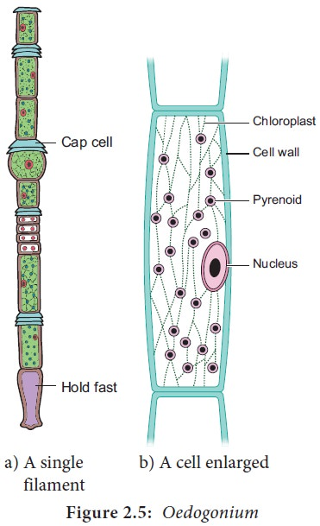

Reproduction

Oedogonium reproduces by vegetative, asexual and sexual methods.

Vegetative Reproduction:
Vegetative reproduction takes place by fragmentation and akinete formation.
(A) Fragmentation:

Oedogonium filament breaks into many small fragments which have capability to grow into complete filaments under favourable conditions.
Fragmentation takes place due to any of the following reasons:
(a) Accidental breaking of the filaments.
(b) Dying or dehydration of intercalary cells.
(c) Disintegration of intercalary cells due to conversion in sporangia.
(d) Mechanical injury to the filament.
(e) Change in the environmental conditions.
(B) Akinete formation:
The akinetes are formed under unfavorable conditions. Akinetes are modified vegetative cells which become swollen, round or oval, reddish brown and thick walled. These are rich in reserve starch and orange-red coloured oil. Akinetes are formed in chains of 10 to 40 (Fig. 4). Akinetes germinate directly under favourable conditions.

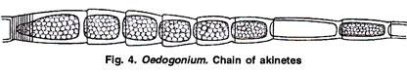

Asexual Reproduction : It occurs during favourable conditions.

Asexual reproduction takes place by means of multi-flagellate zoospores produced singly in intercalary cap cell. Mostly the newly formed cap cell functions as the zoosporangium.
Several factors control zoospore formation of which high pH and CO₂ concentration of medium and a diurnal rhythm of light and darkness are significant. The zoospores are not formed in chains and one sterile cell is always present between two zoosporangia.
The cell which functions as zoosporangium gets filled with abundant reserve food and a slight contraction of the protoplast from the cell wall takes place (Fig. 5 A, B).
The central vacuole disappears the chloroplast frees itself from one end of the cell and becomes conical. The nucleus comes to lie near this chloroplast. A small lens shaped hyaline region is formed between the wall and the nucleus. This hyaline bald spot later forms the anterior end of the zoospore.
At the base of this hyaline area a ring of basal granules appears and from each basal granule or blepharoplast a flagellum arises. The basal granules are connected to each other by fibrous strand. A ring of about 30 flagella is formed around the hyaline spot (Fig. 5 C).
The mature zoospore is oval, spherical or pear shaped structure. The zoospore is uninucleate and contains a ring shaped chloroplast. The zoospore is dark green in colour except at the hyaline pointed apical end. A sub apical ring of flagella is present and such flagellation is called stephanokontic type (Fig. 5 F).
When the zoospore is mature, the wall of the zoosporangium splits near the apical region and the adjacent cell moves apart to make a gap for the liberation of zoospore (Fig. 5 D).
The mucilage substance is secreted at the base of the zoospore which helps in the liberation of zoospore. The zoospore comes out of the zoosporangium in a delicate mucilaginous vesicle which soon gets dissolved and the zoospores are liberated in water (Fig. 5 D, E).
Germination of Zoospore:
After liberation, the zoospore swims for about an hour. Then it settles and attaches itself to a solid substratum with its anterior end downwards. After attachment flagella are withdrawn and it starts elongation. The lower hyaline part elongates to make holdfast and the upper part divides repeatedly to make new filament (Fig. 5 G-I).
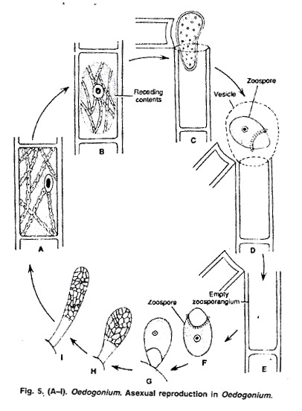
Asexual reproduction in Oedogonium

