Class C Amplifiers
Amplifiers may be classified in many ways according to their configuration, active device used, output, input, their coupling method, frequency range of operation and most significantly their biasing conditions or mode of operations.
The main operating characteristics of an ideal amplifier are linearity, signal gain, efficiency and power output. However, in real world amplifiers, there is always a trade-off between these different characteristics.
On the basis of mode of operation the amplifiers are classified as Class A, Class B, Class AB and Class C Amplifier. Classification of the amplifiers on the basis of mode of operation depends upon the input signal cycle during which collector current is expected to flow.
Analysis of waveforms for different classes of amplifier is shown in Figure 1.
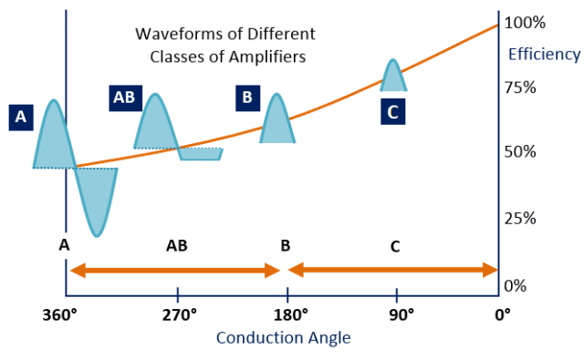
Fig. 1 – Analysis of Wave forms for Different Classes of Amplifiers

Introduction to Class C Amplifier
During a Class C amplifier operation, the collector flows for less than half cycle of AC signal. A class C amplifier is bias for operation for less than 180° of the input signal cycle and its value is 80° to 120°.
Less than 180° (half cycle) means less than 50% and would operate only with a tuned or resonant circuit, which provides a full cycle of operation for the tuned or resonant frequency.
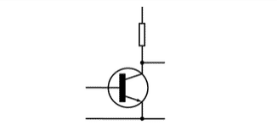
Fig. 2 – Class C Amplifier Symbol
There is a trade-off between efficiency and distortion as the efficiency improves at a large extended level by reduced conduction angle. However, it also leads to a lot of distortion. The Class C amplifiers used in RF transmitters usually are operating at a single fixed carrier frequency.
In such applications, the distortion is controlled by a tuned load on the amplifiers. The input signal is applied to switch the active device (transistor) and so the current is directed to flow through a tuned load.
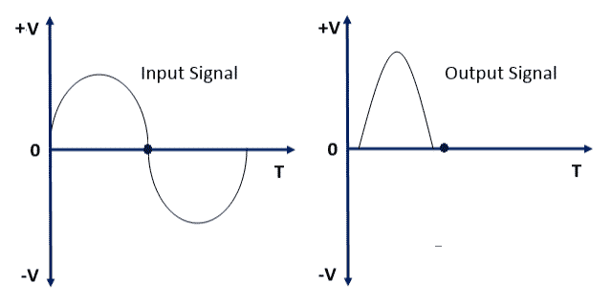
Fig 3. – Input and Output waveform of Class C Amplifier

Working Principle of Class C Amplifier
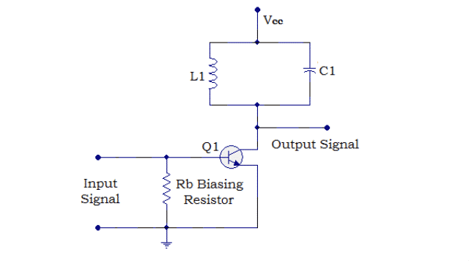
Fig. 4 – Circuit Diagram of Class C Power Amplifier
As shown in the above circuit diagram, Resistor Rb connects to the transistor Q1 base. A biasing resistor which connects to the base of Q1 try to pulls the base of transistor further downwards and set the operating pointer dc bias point below the cut-off point (In cutoff the collector current is I_{CO} which will be of micro amperes order and hence can be assumed to be zero) in the DC load line. The dc load line is the locus of I_{C} and V_{CE} at which BJT remains in active region.
The reason for the major portion of the input signal is absent in the output signal is that the transistor will start conducting only after the input signal amplitude has risen above the base emitter voltage (Vbe~0.7V) and according to the result the downward bias voltage caused by Rb.
As shown in Figure 4, inductor L1 and capacitor C1 forms a tuned circuit which is also called a tank circuit. LC circuits are used either for generating signals at a particular frequency, or picking out a signal at a particular frequency from a more complex signal which extract the required signal from the pulsed output of the transistor.
A series of current pulses is produced by the transistor (active element) according to the input which flow through the resonant circuit. The tank circuit oscillates in the frequency of the input signal by selecting the proper value of L and C. All other frequencies are attenuated by tank circuit and the tank circuit oscillates in one frequency.
The required frequency is obtained by using a suitably tuned load. The output signal noise can be eliminated by using additional filters. For transferring the power to the load from the tank circuit, a coupling transformer is used.
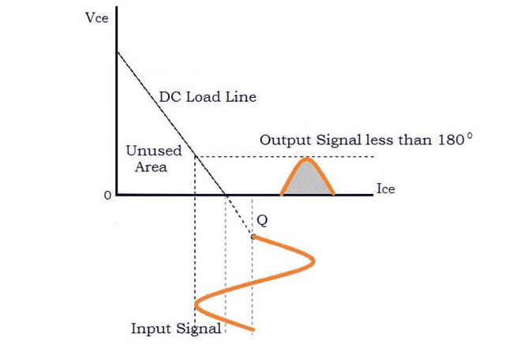
Fig. 5 – Characteristics of Class C Amplifier
As shown in Figure 5, it can be observed that the operating point is placed some way below the cut-off point in the DC load-line and so only a fraction of the input waveform is available at the output.

Applications of Class C Amplifier
Class C Amplifier is used in: –
- RF oscillators.
- RF amplifier.
- FM transmitters.
- Booster amplifiers.
- High frequency repeaters.
- Tuned amplifiers etc.

Advantages of Class C Amplifier
The advantages of Class C Amplifier are as follows: –
- Higher efficiency.
- Best result in RF applications.
- Physical size is suitable for given power

Disadvantages of Class C Amplifier
The disadvantages of Class C Amplifier are as follows: –
- Poor linearity.
- Not suitable for audio applications.
- Lot of noise and RF interference.
- To obtain ideal inductors and coupling transformers it is very difficult.
- Not good dynamic range.

